A PLAYWRIGHT’S MANUAL
By Wally

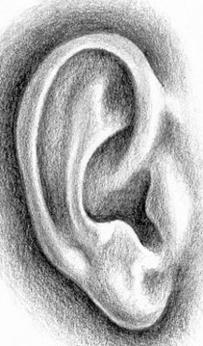

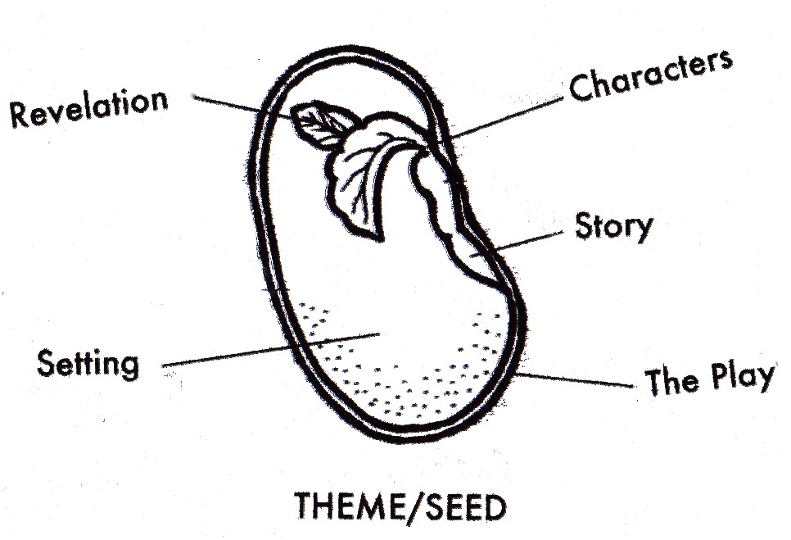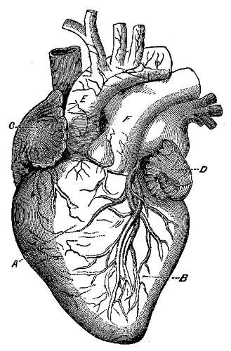
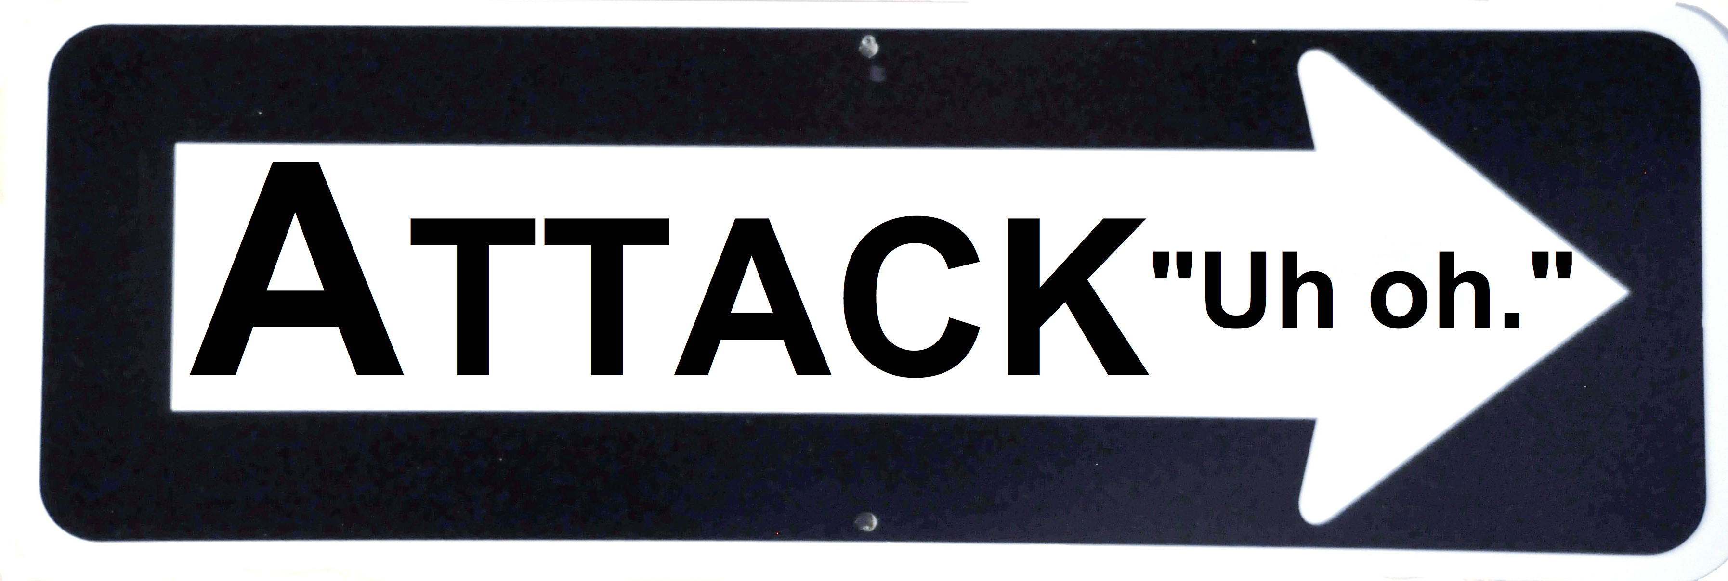
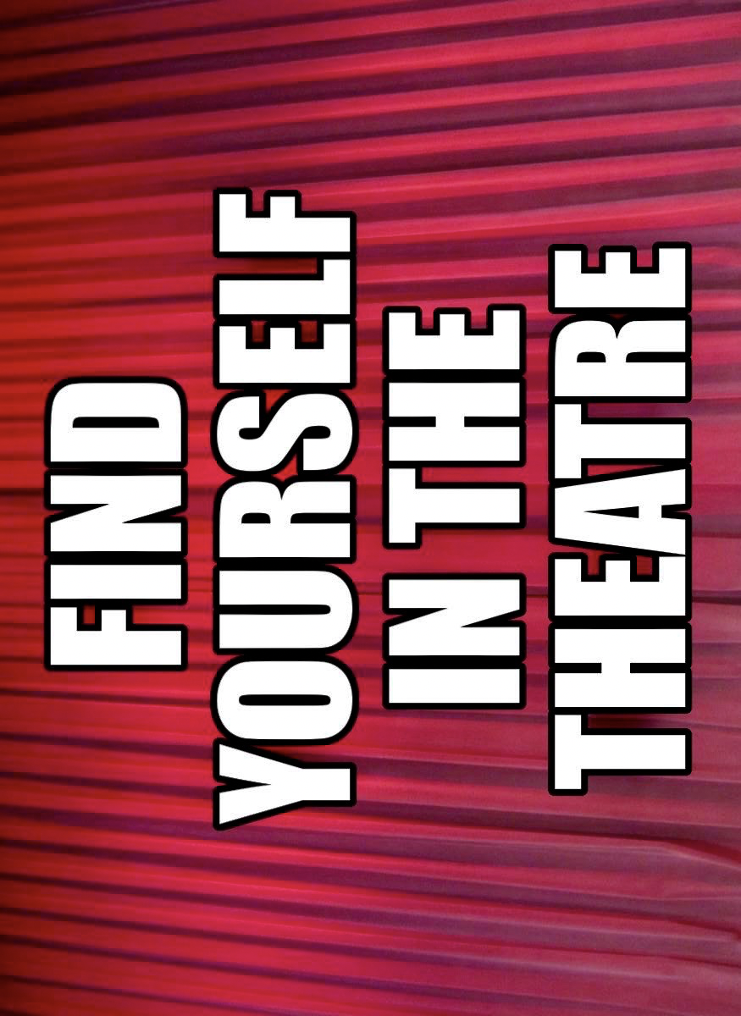
“You must enter the theatre through the world. To make something useful. To provide the useful event that can help us. A theatre not for the people, but at one with people. The theatre of change. Of emergency. Of feeling. When we feel, we will feel the emergency: when we feel the emergency, we will act: when we act, we will change the world. Art is not a profession but a path toward truth both for maker and spectator.”
- Selected quotes from Julian Beck’s the life of the theatre
Theatre brings people together to consider the questions of our time. The word ‘playwright’ uses the root word wright as it means, ‘to create’. This is more than script writing, playwrights manifest worlds that challenge our humanity.

Your experience, imagination and research will provide you a story that is worthy of sharing with an audience.

First listen to the world, and then question it. Plant your question then play gardener and finally, its parent, releasing your provocation on the world. Enjoy yourself while you work, with less judgment and more curiosity. Make the experience that we need and the one that you want to see. Thank you.
- Wally

* www.ebwally.com *
The tools of the trade and the cycle they are used in:
(magnifying glass, telescope, shovel and testing beaker)
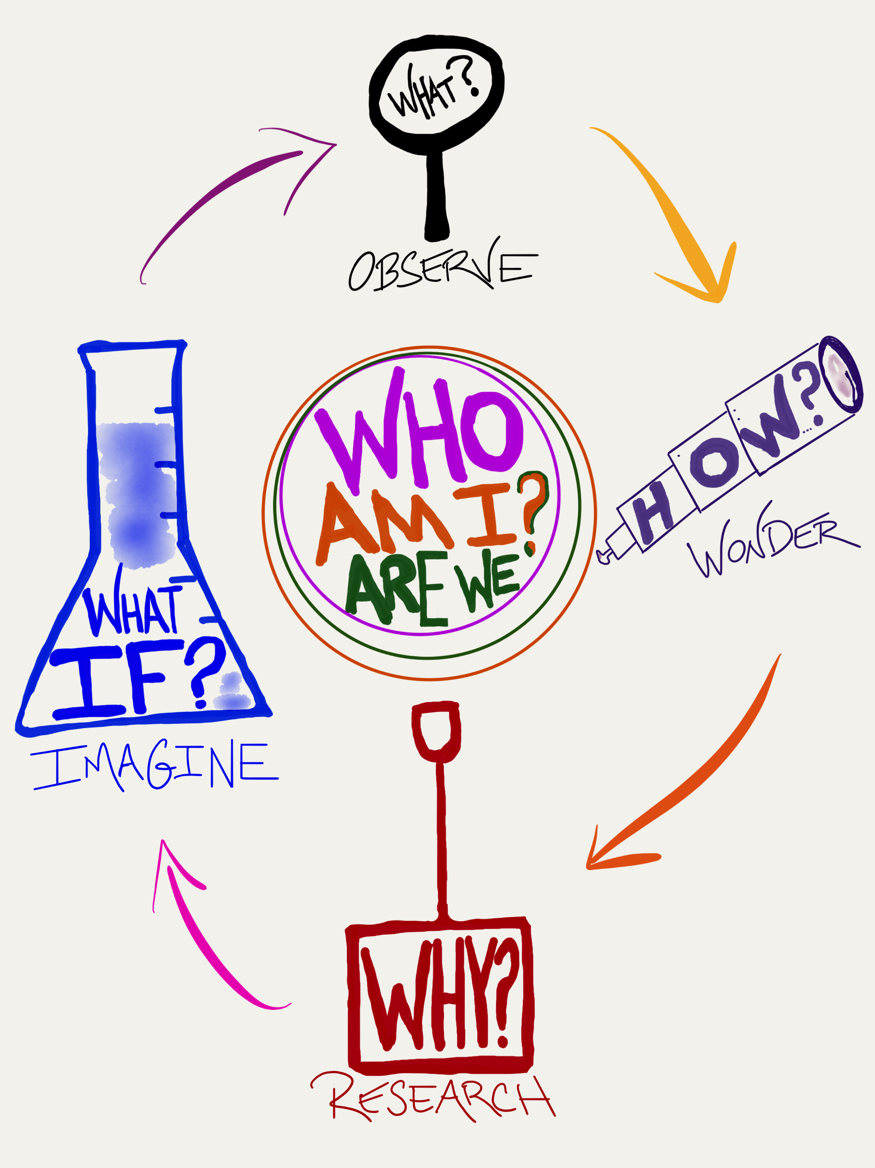
I, THE PLAYWRIGHT

WHAT OBSERVATIONS DO YOU HEAR, SEE, THINK AND FEEL ABOUT LIFE and/or THE WORLD AROUND YOU?
___________________________________________
___________________________________________
___________________________________________
___________________________________________

WHAT IDEA or THEME CONNECTS YOUR OBSERVATIONS?

WHAT CONCERNS YOU THE MOST ABOUT IT?
________________________________________________________________________________________

WHY DOES THIS MATTER TO YOU PERSONALLY?
____________________________________________
IDENTIFY YOUR QUESTION
Using the above word or phrase, write a QUESTION that your play will ask its audience? Begin with HOW.
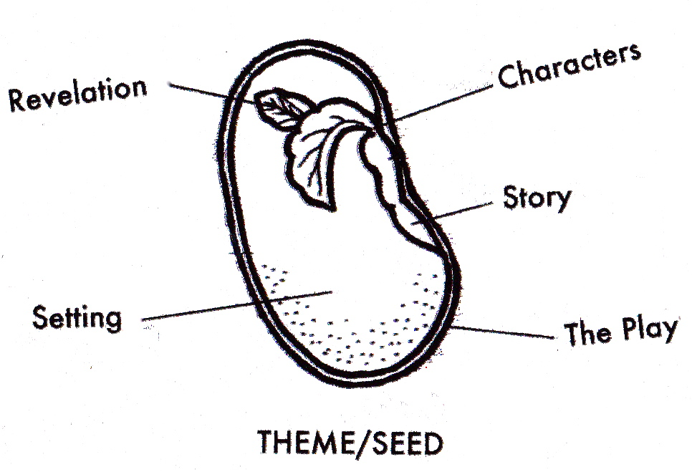

HOW_________________________________________________________________________________________________?
BUILDING CHARACTERS

What questions matter for the modern audience? Redraft your QUESTION, dig deeper, go further.
HOW_________________________________________________________________________________________________?
WHAT CHARACTERS CAN BEST WRESTLE WITH THIS QUESTION?
Write a CHARACTER description:
(include NAME, gender/age, important physical and personality details)
____________________, _____, ________________________________________, _______________________________________________________________________________________________________________________________________.
Write a description of an opposing CHARACTER:
(include also their relationship to the main character)
____________________, _____, ________________________________________, _______________________________________________________________________________________________________________________________________.
What SETTING will best challenge the characters?
TIME: ____________________________________________ PLACE:___________________________________________
Setting Description: What is on stage?
________________________________________________________________________________________
Opening stage direction: What is happening after ‘lights up’?
____________________________________________________________________________________________________________________________________
PLAY FORMAT
_______________________________ (centered title)
by __________________________ (playwright’s name)

CHARACTERS: (NAME, age, physical and personality description)
_________________, ____, _________________________________________, ________________________________________________________________.
_________________, ____, _________________________________________, ________________________________________________________________.
TIME: ______________________ (when and where is this PLACE: ______________________ happening? be specific)

SETTING: (The opening frame, what is on stage?) ____________________________________________________________________________________________________________________________________________________________________________________________________________

(What’s happening? Action!)
(______________________________________________________________________________________________________________________________________________________________________________________________________________________________________________________________________________)

CHARACTER: There are free online programs that can format your scripts.

CHARACTER 2: Duh. There’s an app for everything.

---- OR A CENTERED FORMAT ----

CHARACTER
When you center a character’s name it is not underlined and it does NOT get a colon. Puh-lease!

CHARACTER 2
The two dots, I get it. Okay. Okay. What’s the app?

(CHARACTER takes out a laptop and types in https://www.celtx.com.)
SCRIPT NOTATION
Stage Directions
Within parenthesis and/or italicized, descriptions of what is happening on stage, how and where? Stage directions commonly used are for:

ACTION - what is happening and where is it located
(Lou runs off up left.)
RELATION - specifying who or what a character is talking to
(to the audience) or (aside) or (to [a specific character])
QUALITY - to convey how a character expresses something, three words or less, before the spoken line
(nervous), (whisper) or (overlapping)
TEMPO - composing rhythm of thought throughout dialogue
(beat), (pause), (long pause) and (silence)
TECHNICAL - sounds or songs that are heard and any important shifts in light, video or projections
(The song “Blue Moon” is heard. A bright light flashes.)
Punctuation
Few people speak in proper English. Playwrights use punctuation to help convey the rhythm of speech and a character’s listening and thinking.
. = the period means a full stop
, = a comma means a slight pause
… = ellipses conveys thought interrupting word flow
- = hyphen specifies being cut off
! = exclamation points make a line louder (≤ 3)
CAPS = the loudest possible
Avoid unnecessary use of profanity, random punctuation, Capitalizations and missing words. Always capitalize the first letter of a sentence and finish with a punctuation mark. Use as few words as possible. Lastly, write so you can be understood.
SIGNPOSTS OF STORYTELLING

DESCRIBE the journey this question will take, the plot points.
WHAT HAPPENS?

“Uh oh!” the problem and question begin to form for the audience.

_______________________________________________________________________________________________________________________________________________________________________________.

“OH NO!” What are we going to do?!

_______________________________________________________________________________________________________________________________________________________________________________.

“OH!” now I see the solution, the way forward.

_______________________________________________________________________________________________________________________________________________________________________________.

RESEARCH
Push your thought onward, dig deeper. Ask a question that leads to more questions.
Your play wants to follow the theme/seed toward its greatest expansion.

TO DO: Listen to the world around you. Look at everything and be prepared to write all of your thoughts or dialogue as it comes. Always have a notebook available.

What do you know about your theme?
Make a list of as many things you are sure about.

What don’t you know about it?
Make a list of QUESTIONS you have.

What are you looking for? Where can you find answers?
Make a list of resources and people you can go to.

List three keyword searches:
1. _______________________________________________
2. _______________________________________________
3. _______________________________________________
Story WEBSITES
Five sources for real life stories.
Search these websites with your theme/seed’s keywords. Write the name of the stories you listen to on the lines below:

THIS AMERICAN LIFE www.thisamericanlife.org
Features investigations and stories around central themes. Podcast available. Search the Archive.
____________________________________________________________

THE MOTH RADIO HOUR www.themoth.org
The Moth Radio Hour features true stories told live on stage without scripts or notes. Podcast available. Search the Archives.
____________________________________________________________

DEMOCRACY NOW! Independent Global News www.democracynow.org Non-commercial fact-based journalism. Daily news hour investigates what is happening in New York and around the world. Amy Goodman hosts. Podcast and español available. Search the Archives.
____________________________________________________________

STORY CORPS www.storycorps.org
StoryCorps provides Americans the opportunity to share, record and preserve the stories of our lives. Since 2003, StoryCorps has collected and archived more than 50,000 interviews all accessible on their website.
____________________________________________________________

THE NEW YORK TIMES www.nytimes.com
Since 1851, a world’s worth of stories. Pick up a copy or read it on-line. Search the archives.
____________________________________________________________
MULTI-MEDIA APPROACHES

NOW find images, articles, songs, videos and text that can enrich the play.
Identify material that illuminates aspects of your theme/seed.

What outside KNOWLEDGE or TEXT can be useful?

What song(S) or type of music do you hear?

What type of DANCE or MOVEMENT do you see?

What IMAGES do you see?

What VIDEO or moment from a MOVIE is usable?

NOW create an online document to store material.
Compile then look and listen to it all.
QUOTES
Some playwrights begin their plays with a quote that contains the secret history of the play itself.
Madeleine George’s Hurricane Diane (2017)
“What I want is what I’ve always wanted. What I want is to be changed.”
- Mary Szybist, Incarnadine

August Wilson’s The Piano Lesson (1990)
“Gin my cotton
Sell my seed
Buy my baby
Everything she need”
- Skip James

Tony Kushner’s Angels in America - Part One: Millennium Approaches (1991)
“In a murderous time
the heart breaks and breaks
and lives by breaking.”
- Stanley Kunitz, “The Testing-Tree”

What quote can lead us into your play? Note it here:

______________________________________________________________________
______________________________________________________________________

DEDICATION
Most playwrights will dedicate the play to someone that has a relationship to the play and/or to the playwright.

Quiara Alegria Hudes’ The Happiest Song Plays Last (2013)
“For Virginia and Sedo Sanchez -- mom and pop -- who blasted Ramito way too early in the morning.”
Spalding Gray’s Swimming to Cambodia (1985)
“To the Cambodians and Cambodia, a country beyond my imagination and much too far to swim to.”

To whom or what will you dedicate your play? Note it here:

______________________________________________________________________
______________________________________________________________________
Play Formatting

The play’s title uses a font that conveys the feeling of the play. It is standard to use 14 pt. Times New Roman for the play’s text. Italicize and/or parenthesis all stage directions. Here are two examples of different formats:
______________________________________________________________________
Winterville
By Eric Wallach
“She is so raped right now.” – Michael Nodianos
Winterville is dedicated to the survivors of violence.

CHARACTERS
AUDRIE BUTLER, 16, good looking girl with piercings and dark eyeliner. Book smart but naïve.
BRIAN BUTLER, 35, (Audrie’s Father), short haircut with a farmer’s build. He is an Iraq War veteran working as a security guard who shares custody of his daughter.
MONIQUE WILSON, 34, (Audrie’s Mother), a charming travel agent; powerful, healthy and wise.

TIME: September 2012, first day of school
PLACE: Brian Butler’s Home, 722 Dean Martin Blvd, Winterville, Ohio
The stage conveys a one family home protected by white aluminum siding that is falling off at the edges. In the home we see AUDRIE’s bedroom which is decorated somewhere between her pink child’s room and the modern suburban young lady. Everything else in the house seems just above poverty. The back wall is used as a projection screen upon which texts and AUDRIE’s screens can be seen.
Downstage there is a ‘front lawn’. Lying face down on the grass is AUDRIE. Her shoes and phone are by her side. She doesn’t move much as the audience enters. Quiet sounds of Winterville waking up are heard. Cars and trucks passing, birds chirping and a cool wind blowing. We hear Sam Cooke crooning ‘Trouble Blues’.

(A doorbell, ding-dongs as houselights go dark quickly. BRIAN, dressed in a security guard uniform, opens the front door and sees AUDRIE.)

BRIAN: (panic) Hey! Hey. (running to her) Hey Audrie, whaddya doing? You couldn’t make it to the door? Come on, get up. (silence) Get up Audrie, what the … I’ve got to get to work and you’ve got school. Get up, now … (intensely) COME ON! Audrie! Hey. (to the audience) What happened? ...

Interview
or
Who’s Afraid of Mr. Albee?

a play in one scene
by
Eric Wallach

Based on an interview with Edward Albee by Eric Wallach at Mr. Albee’s Tribeca loft in New York City on March 15, 2005.

“No one should come to New York to live unless he is willing to be lucky.”
- E. B. White, Here is New York

CHARACTERS

MR. ALBEE: A playwright who has just turned 77. He’s dressed in muted earth tones, has a moustache and glasses. Although he is moving past middle age, his dress and his manner would suggest a man younger.

INTERVIEWER: A director who has just turned 33. He is smartly dressed with a style of his own, a beard and glasses.
-------------------------------

Lights up on Mr. Albee’s large Tribeca loft, full of art and African furniture. A leather couch sits off center with a black swivel chair to its left with a large square dark wooden table in front of both. Sunlight pours in through the windows behind our scene.

(As the curtain rises, the INTERVIEWER is seated on the corner of a couch and is looking over his pages on a clipboard. He stops reading, cleans his glasses, goes back to reading. MR. ALBEE enters.)

MR. ALBEE
Good morning.

INTERVIEWER
(He gets up and shakes MR. ALBEE’s hand) Good morning. (Sitting down again, he sets up his minidisk recorder and microphone between them) How, uh, how are you today?

________________________________________________________________________________________________________________________________________________________________________________________________________________________________________________________________________________________
________________________________________________________________________________________________________________________________________________________________________________________________________________________________
________________________________________________________________________________________________________________________________________________________________________________________________________________________________
________________________________________________________________________________________________________________________________________________________________________________________________________________________________________________________________________________________
________________________________________________________________________________________________________________________________________________________________________________________________________________________________________________________________________________________
________________________________________________________________________________________________________________________________________________________________________________________________________________________________
________________________________________________________________________________________________________________
________________________________________________________________________________________________________________________________________________________________________________________________________________________________________________________________________________________________________________________________________________________________________________________________________________________________________________________________________________________________________________________________________________________________________________
________________________________________________________________________________________________________________________________________________________________________________________________________________________________
________________________________________________________________________________________________________________________________________________________________________________________________________________________________
________________________________________________________________________________________________________________________________________________________________________________________________________________________________________________________________________________________
________________________________________________________________________________________________________________________________________________________________________________________________________________________________________________________________________________________
________________________________________________________________________________________________________________________________________________________________________________________________________________________________
________________________________________________________________________________________________________________
________________________________________________________________________________________________________________________________________________________________________________________________________________________________________________________________________________________

ELEVATOR PITCH

IMAGINE that you have a chance to inspire a producer to send your play into production. You only have a couple of minutes between the first floor and the penthouse. What will you say?
The play asks the world today (enter theme/seed here) ____________________________________________________________________________________

TITLE _____________________________________

SETTING (when and where in the world) ________________ ____________________________________________________________________________________

CHARACTERS ____________________________________________________________________________________

PLOT (briefly, what happens?) ____________________________________________________________________________________

REVELATION (what does the audience learn?)
__________________________________________
__________________________________________
AUDIENCE RESPONSE SHEET
How was your play-going experience?
_________________________________
_________________________________ _________________________________
WHAT DO YOU REMEMBER HEARING, SEEING, THINKING & FEELING? WRITE AT LEAST ONE DETAIL FOR EACH:

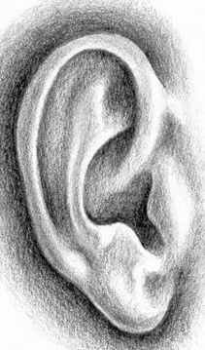 ___________________________________________
_________________________________________ __________________________________________
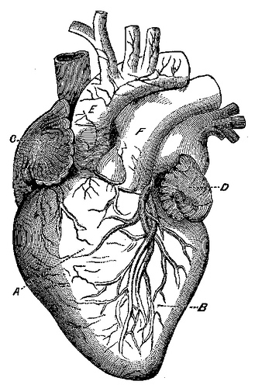 _________________________________________
ADD the observations up. What theme or thought is the show most about to you? Write a word or two here:
_____________________________________________
Using the above word(s) write a QUESTION that you observe the show is asking its audience.
How_______________________________________________________________________
Describe the moments that the story turns on.
What happens?
“Uh oh!” The Question begins to form in our mind.

_______________________________________________________________________________________.

“OH NO!” The Question is at it’s most intense. What are we going to do?! Everything stops until change comes.

_______________________________________________________________________________________.

“OH!” Now we see the way forward.

___________________________________ _________________________________________.
……………….….
HOW DO YOU PERSONALLY CONNECT WITH THE QUESTION?
_________________________________
_________________________________ __________________________________________________________________

THE PLAYWRIGHT’S RUBRIC
Plays come from experience (the source of your brilliance), imagination (where anything and everything is possible) and research (where you discover truths that are worth sharing).
Plays are an opportunity for others to listen to your perspective. Offer your knowledge. Make the theatre you would like to see.
A GOOD PLAY - tells a story - follows the play format - connects with the audience - introduces interesting characters - has an Attack, Crisis and Revelation - conveys a clear question and direction forward
A GREAT PLAY - is a “good play” plus it uses music, sound, lights, color and movement - surprises the audience - instigates compelling moments - uses the stage creatively
AN EXCELLENT PLAY - is a “great play” plus it challenges important issues - inventive – emotionally open - funny and provocative - unforgettable

