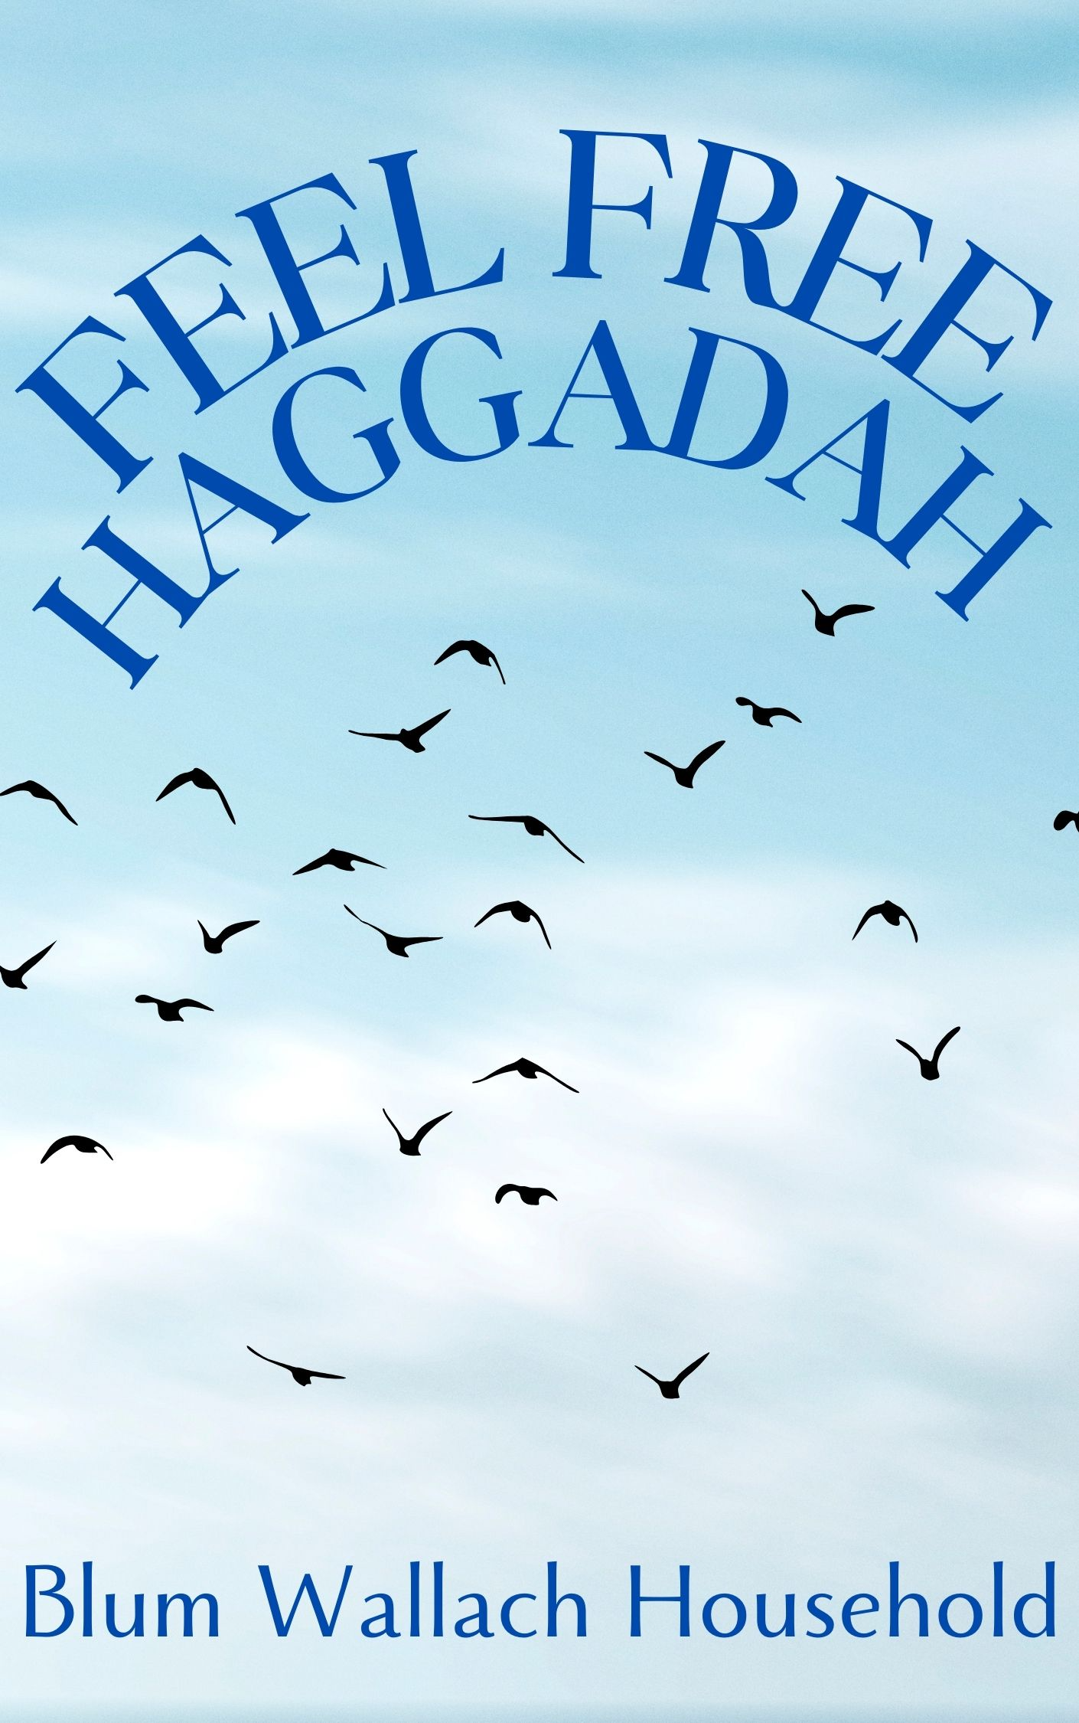The Feel Free Haggadah
Compiled, edited and written
by Eric “Wally” Wallach with Belinda Blum
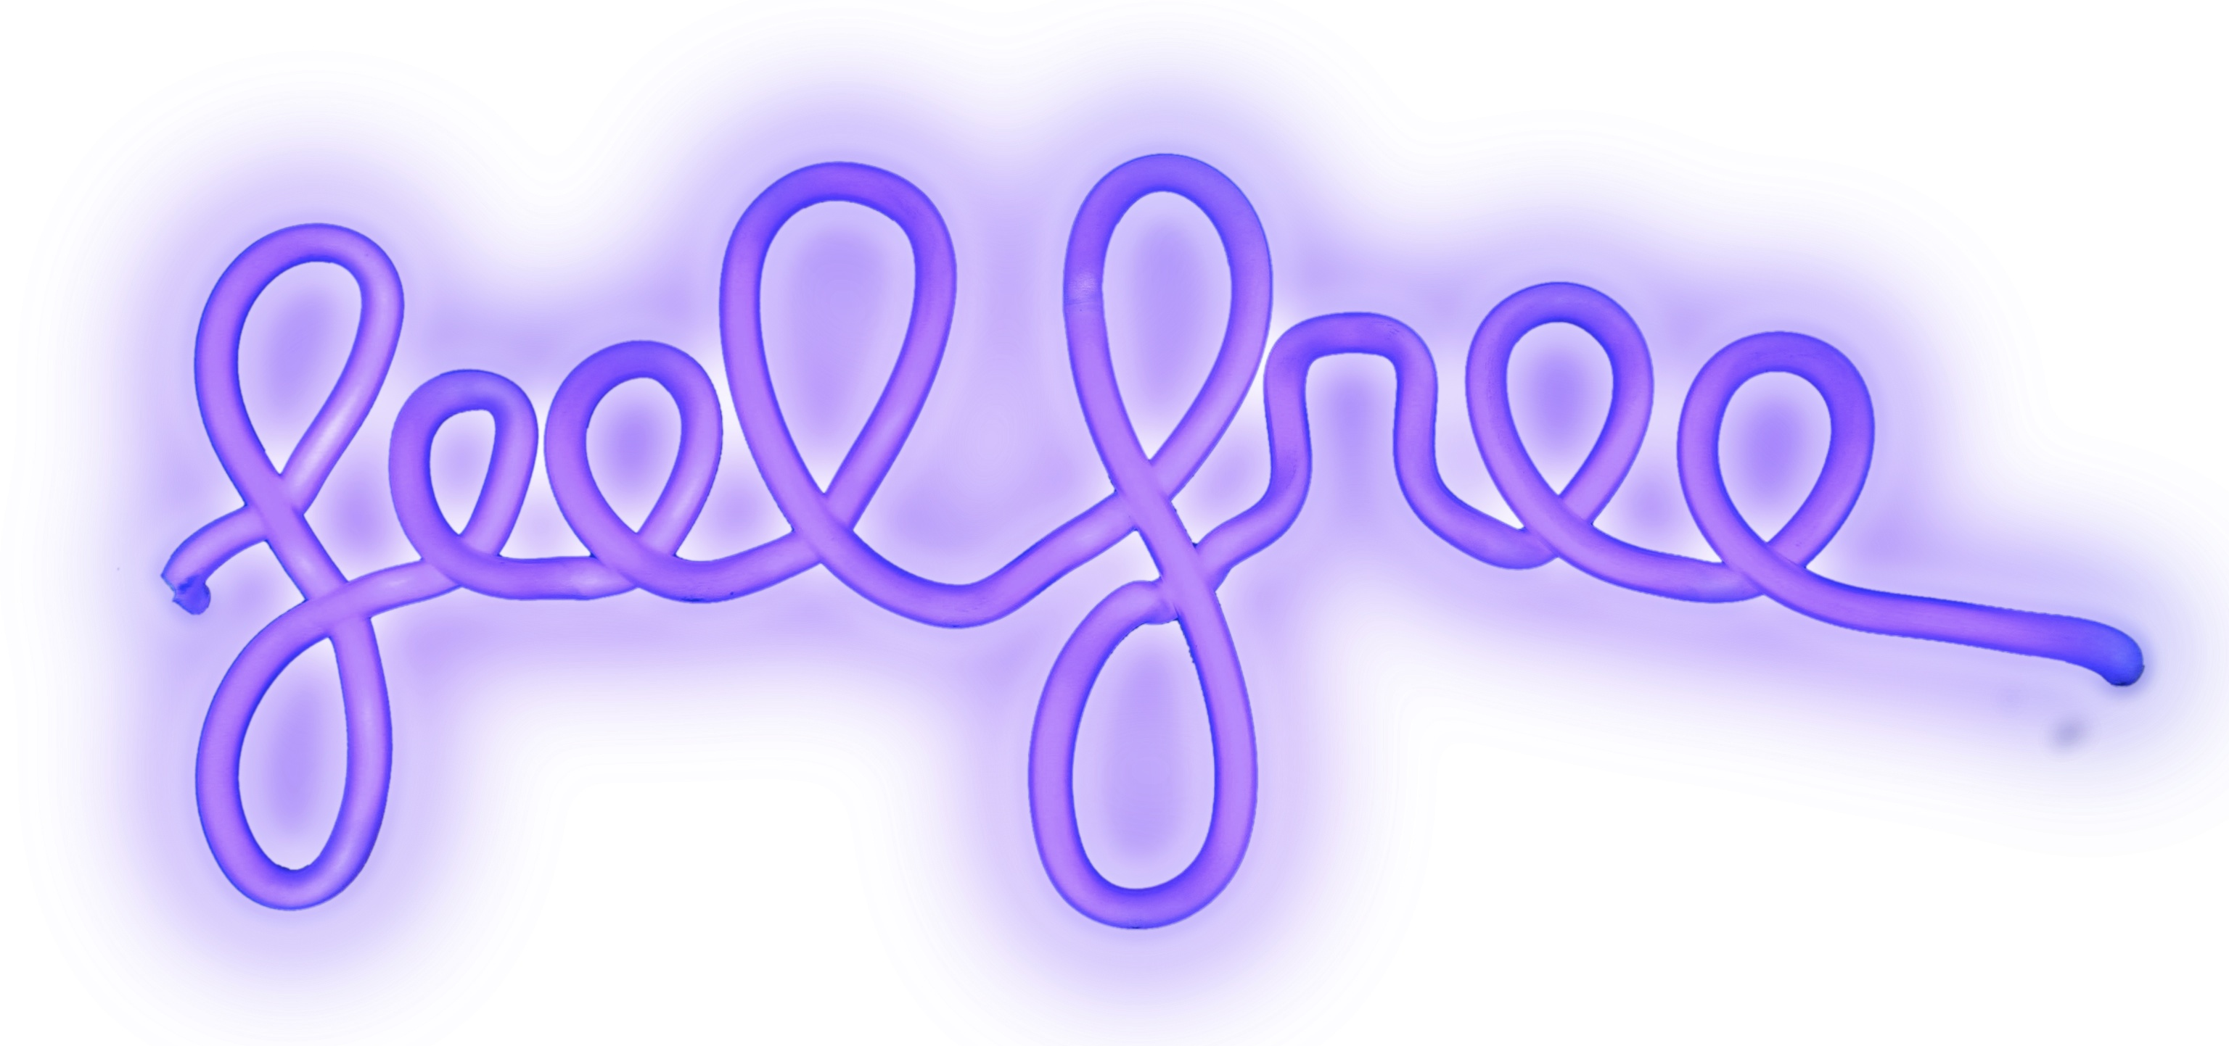
SEDER
Seder means "order.” We begin with the simanei ha-seder ''the guideposts of the Seder" that provide direction and structure for our evening.
INTRODUCTION / DEDICATING TIME / CANDLE LIGHTING ... 2
QUESTIONS …...……………………………………………………....... 3
Hand Washing IN MIRIAM’S WELL ……………………………… 4
“On the Pulse of the Morning”………………………………… 5
Karpas / CUP #1 KIDDUSH / Yachatz – Breaking bread 6/7
DAYENU …………………………………………………………………... 8
MAGGID / THE FOUR QUESTIONS ………………………………….. 9
SEDER PLATE …………………………………………………………….. 11
Why an olive? / AN ORANGE? …………………………………… 12
CUP #2 …………………………………………………………………… 13
MOSES IN FIVE ACTS: a play to share on Passover …………….……… 14
MORE QUESTIONS / FOUR QUESTIONS ……………………………. 19
CUP #3 /ANNE FRANK ………………………….…………………….. 20/21
ASMAA MAHFOUZ’S JANUARY 18, 2011 POST .………………..….. 22
WELCOME ELIJAH / ASMAA’S JANUARY 24, 2011 POST .……….. 23/24
GET OUT OF EGYPT …………………………………………………… 25
ASMAA’S JANUARY 26, 2011 POST …………………………………. 27
CUP #4 / AFIKOMEN FOUND …………………….………………….. 28 POETRY & SONG FREE FOR ALL! ……………………………………. 29

Note: Words in italics are actions and words in bold are spoken by all. Cover art by Ruby Sunrise and back cover by Alexander Gorlizki.

INTRODUCTION Ring bells.

“We in this room don’t want to practice Orthodox Judaism, but we often define ourselves in the negative by Orthodox standards. “I’m not religious,” some might say, even as you sit here. It’s time to articulate our Judaism by our own standards, in the positive. … Our vision of Judaism includes Haredi Jews. It’s a vision of a people who unite across our differences to fight antisemitism and make the world more whole. But a black hat does not make a person more Jewish, just like being a man does not make a person more Jewish. If you are a Jew, there is no one on earth more Jewish than you. No one. Whatever kind of Jew you are, Own it. Step up into it. Fall in love with it. Our history depends on it. We are the Jewish people.”
- Rabbi Rachel Timoner (Rosh Hashanah, 5784)

Now let us begin our task. The Talmud teaches that it is not our responsibility to finish our task but it is our responsibility to begin it.
Here I am ready and prepared to fulfill the mitzvah of doing.
Before the beginning of a great change and revolution, you must declare your intention. The seder wants us to be active participants.

Join hands and name everyone at the table, present and at heart.

We are grateful that we are all here together. Now, take this moment to declare your intention.
Listen to everyone’s intention.
Love, love, love, and gratitude.

DEDICATING TIME

Passover signals the beginning of a new relationship with time, time marked not only by the endless cycles of nature but by the surprising events of our own history. By dedicating time, we become masters of the moment and make the moment eternal.

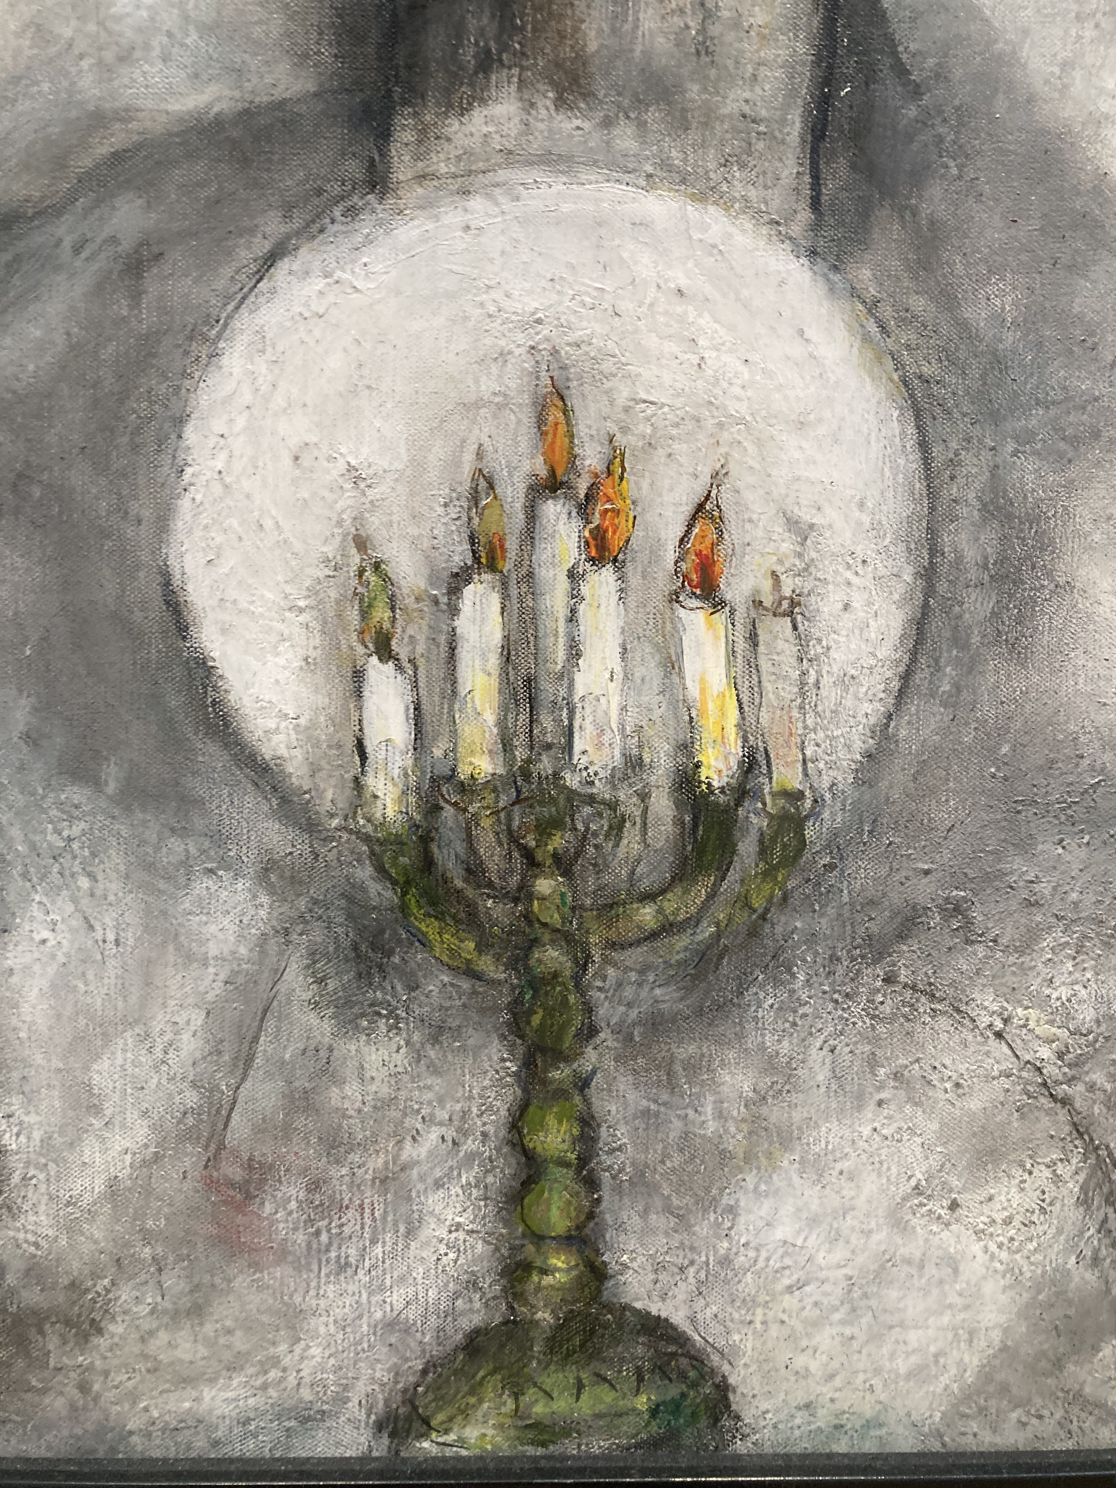
Detail of Marc Chagall
CANDLE LIGHTING

You abound in blessings, Eternal One,
Sovereign of all time space
who brings holiness to our lives with
the command to kindle the light of the festival.

Barukh attah adonai eloheinu melekh ha-olam asher kiddeshanu be-mitzvotav ve-tzivanu le-hadlik ner shel yom tov.

Light candles.

QUESTIONS

Questions are not only welcome this evening but are vital to tonight’s journey. We remember that the root of the word ‘question’ is ‘quest’ and that questioning itself is a sign of freedom. Questions lead us on our journey.

QUESTIONS 1963/1968 by Julian Beck edited for Passover

what is the difference between questions and answers
is it good to change
are you content
are you content with anything
what do you enjoy
do you know how to love
do you love, are you loved
what is useful, what is a good question
what is a way to find answers
what do we need, how can we get it
how do we feed all the people
how do we stop all the wars
how do we open the doors of all the jails
how do we disintegrate the violence
how do we obliterate racism
how do we get rid of money (capitalism)
how do we end militarism
how do we put an end to authoritarian systems
how do we end the class system thing
how do we find the answers to these questions
how do we do it now

Hand Washing

As we wash our hands let each of us answer the question:
DO YOU FEEL FREE? WHAT DOES FREEDOM MEAN? Discuss.

Three volunteers: One carries a tray upon which everyone places their jewelry, to be returned when the Afikomen is found. One carries a pitcher of water and pours water over each guest’s hands with a second one who carries a basin and towel.

SLAVERY TODAY: An estimated 50 million people were living in modern slavery on any given day in 2021. This is nearly one in every 150 people in the world. (www.walkfree.org) An American slave, part of the prison system, will cost you an average max 52 cents/hour. A Rohingya person captured fleeing Myanmar can cost as little as $7 whereas a Libyan slave can go for $400-$800. Slaves worldwide: 71% are women, 25% are children.

WASHING IN MIRIAM'S WELL

Blessed are those who trust in the Eternal ... they shall be like trees planted by streams of water. - Jeremiah 17

We now fill Miriam's Cup, evoking Miriam's Well, in conjunction with the ritual of Urhatz, the washing of the hands.

Washing, rehitzah, in Aramaic, the language of the Talmud, means "trust."
We recall tonight the waters that evoke trust:
Miriam was there at the Nile, watching over her brother,
and Miriam was there at the Sea, leading the women in song and dance. Legend tells of Miriam's Well, a well filled with mayim hayyim,
living waters of hope and trust, that accompanied the people
throughout their wandering in the desert as long as Miriam was alive.
For 40 years, wherever they wandered, Miriam's Well followed, and sustained them with its nourishing waters.

Tonight, at our Seder, we are still on that journey,
and recall all the women from Miriam's time until our own who helped us know the waters of life and trust.

If it wasn't for the righteousness of the women of every generation
we would not know redemption.
(Play Bob Marley’s “Redemption Song”.)

From “On the Pulse of Morning”, 1993
by Maya Angelou
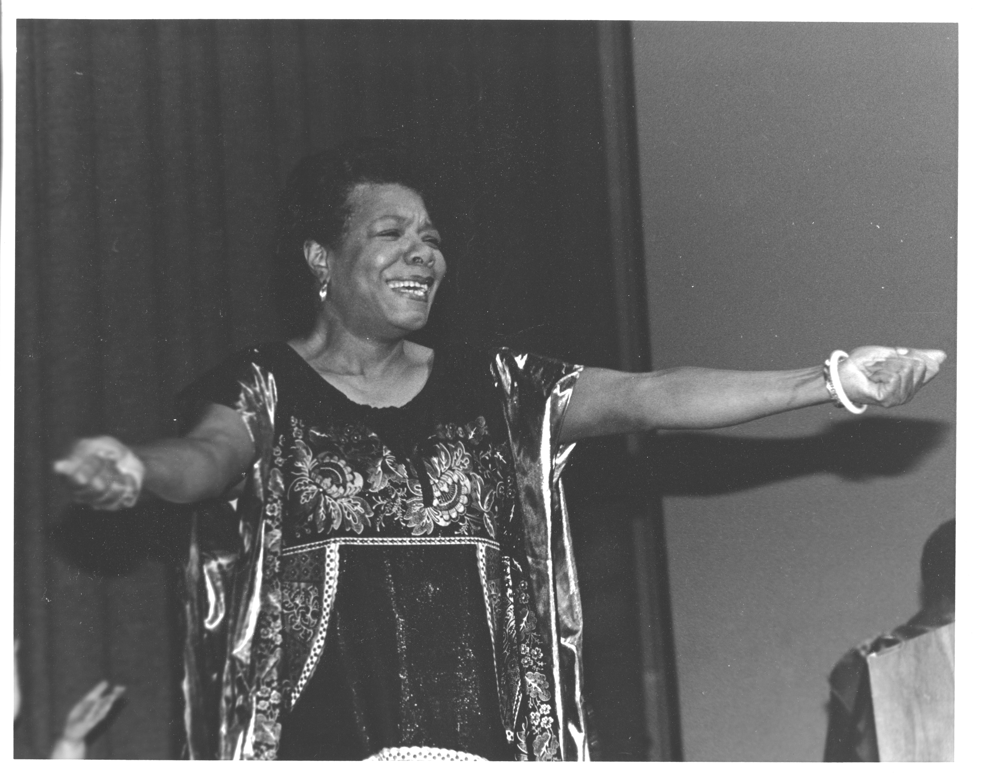 Photo by Belinda Blum

Here, root yourselves beside me.
I am the tree planted by the river,
Which will not be moved.
I, the rock, I the river, I the tree
I am yours--your passages have been paid.
Lift up your faces, you have a piercing need
For this bright morning dawning for you.
History, despite its wrenching pain,
Cannot be unlived, and if faced with courage,
Need not be lived again.
Lift up your eyes upon
The day breaking for you.
Give birth again
To the dream.
Women, children, men,
Take it into the palms of your hands.
Mold it into the shape of your most
Private need. Sculpt it into
The image of your most public self.
Lift up your hearts.
Each new hour holds new chances
For new beginnings.

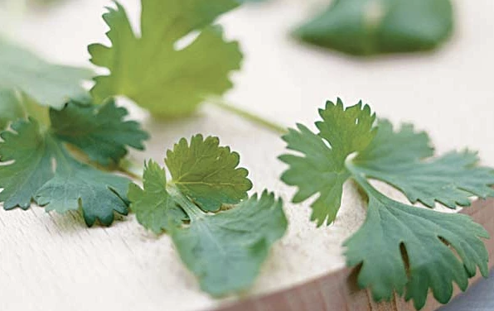
Karpas
Take a piece of parsley and dip it in salt water.

We have become slaves to the cities we build and to the cars we drive. Have we forgotten that it is the soil from which humanity came, the earth which each year displays the miracle of creation?
As Spring re-awakens all that is green, let us re-awaken our ties to the natural world and our bonds to the earth. We dip greens into salt water and acknowledge the tears of slavery and that through our existence there is a purpose to the universe. We are partners in the work of Creation.
Blessed are you, Breathing Spirit of the Universe, who creates the fruit of the earth. Barukh atah a-do-noy elohenu me-lech ha-olam boray p'ri ha a-da-mah.
Everyone eats the parsley.
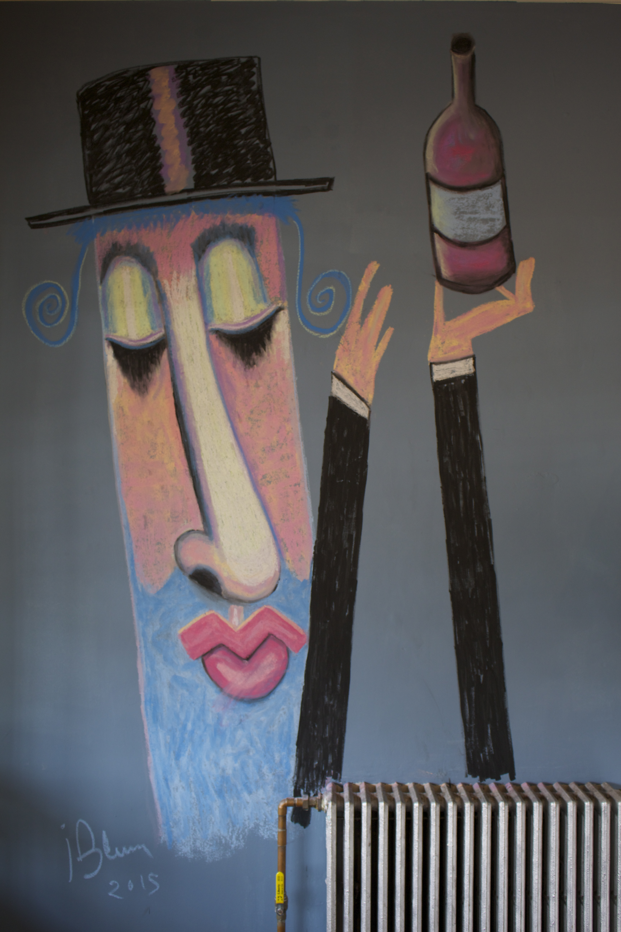 By Jonathan Blum

WINE / CUP #1

We will drink from four cups of wine to honor FOUR STAGES on the path of LIBERATION. These cups are (1) Becoming aware of oppression, (2) Opposing oppression, (3) Imagining alternatives, (4) Accepting personal and communal responsibility to act. Here’s to the awareness that we are subjects of oppression, and that we live in a prison, military, and surveillance state.

Raise glass.
Wine symbolizes the joy and happiness of liberation for all.

BO-RUCH A-TOH A-DO-NOY, E-LO-HAY-NOO ME-LECH HO-O-LOM, BO-RAY ‘PREE HA-GO-FEN.
Blessed are you, Spirit of the World, who has breathed life energy into us, who has provided us with the experiences that have made us who we are. L’chiam.

Make eye contact with everyone then drink while reclining.
Make eye contact again before resting your glass.

Yachatz – Breaking bread

“There’s a crack in everything, that’s how the light gets in.”
– Leonard Cohen Play Leonard Cohen’s Anthem. Listen.

We break the matzah and hide one part, the Aﬁkomen. We recognize that liberation is made by imperfect people, broken, fragmented — so we can’t wait until you are totally pure, holy, spiritually centered and psychologically healthy to get involved in tikkun (the healing and repair of the world).
It will be imperfect people, who do the healing as we simultaneously work on ourselves.

Break the middle matzah on the matzah plate. Raise the middle matzah so that everyone can see it and say:

BO-RUCH A-TOH A-DO-NOY, E-LO-HAY-NOO ME-LECH HO-O-LOM, HA-MO-TZEE LE-CHEM MEEN HO-O-RETZ.

This is the bread of affliction. Let everyone who is hungry come and eat.
We who identify with tikkun proudly proclaim there is enough, we are enough, and we can afford to share.

CAN WE REALLY FEED EVERYONE? Discuss as the Afikomen is hidden.

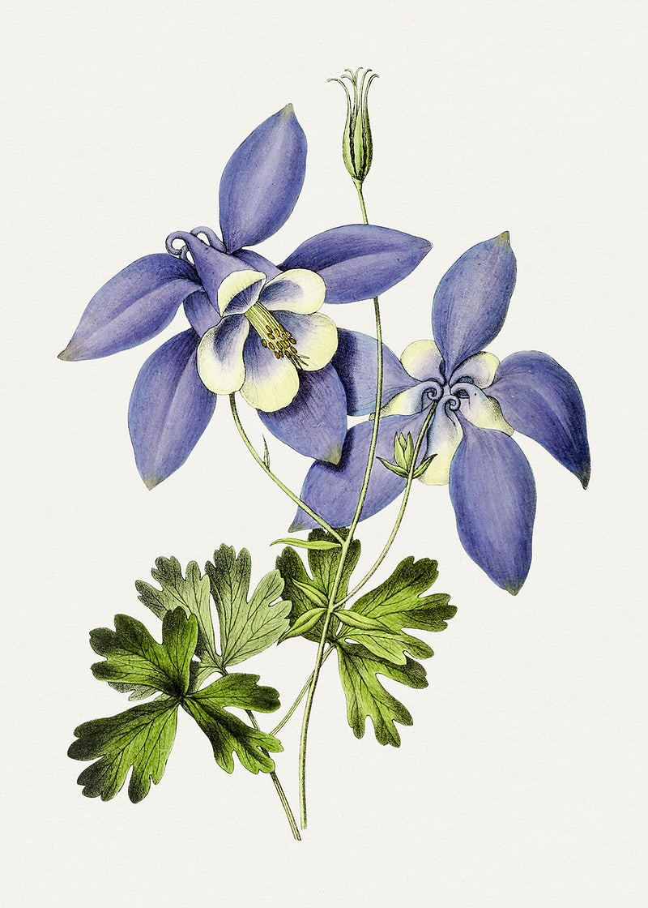

DAYENU (Enough)
Refrain
Dai, dayenu, dai dayenu,
Dai dayenu, dayenu, dayenu, dayenu (repeat)
1. Ilu hotzi hotzianu
Hotzianu mimitzrayim,
Hotzianu mimitzrayim,
Dayenu Refrain
2. Ilu natan natan lanu
Natan lanu et hatorah
Natan lanu et hatorah
Dayenu Refrain
1. Had he brought us out of Egypt,
Only brought us out of Egypt,
Had he brought us out of Egypt,
It would have been enough.
2. Had he given us the Torah,
Only given us the Torah,
Had he given us the Torah,
It would have been enough.

“IZZY, DID YOU ASK A GOOD QUESTION TODAY?”

Isidor I. Rabi, the Nobel laureate in physics was once asked, "Why did you become a scientist, rather than a doctor or lawyer or businessman, like the other immigrant kids in your neighborhood?" He responded, "My mother made me a scientist without ever intending it. Every other Jewish mother in Brooklyn would ask her child after school: ‘Did you learn anything today?’ : But not my mother. She always asked me, “'Izzy,' she would say, 'Did you ask a good question today?'” That difference - asking good questions - made me become a scientist." (Donald Sheff, New York Times, Jan. 19, 1988)

MAGGID – TELLING OUR STORY

Our journey to freedom begins with three sentences that suggest our story must be told in all three dimensions of time: past, present and future.
Our story starts out by recalling our distant past, the time when ‘’we were slaves to Pharaoh in Egypt.”
Now that we are free, our narrative tells us we must reach out to all who are in need: “Do not oppress the stranger; you know the heart of the stranger, for you were strangers in the land of Egypt.” (Exodus 23:9)
“You shall love the stranger as yourself, for you were strangers too.” (Leviticus 19:34) And always, our story leads us to imagine a time when all will one day be completely free: “And each person shall sit under his own vine and fig tree, and none shall make him afraid.” (Micah 4:4)

THE FOUR QUESTIONS MA NISHTANA

Mah nishtanah halyla hazeh mikol halaylot

1) She'bechol halaylot ain anu matbilin afilu pa'am echat, halyla hazeh shtei pe'amim?
2) She'bechol halaylot anu ochlim chametz o matza, halyla hazeh kulo maztah?
3) She'bechol halaylot anu ochlim she'ar yerakot, halyla hazeh maror?
4) She'bechol halaylot anu ochlim bain yoshvin bain mesubin, halyla hazeh kulanu mesubin?

HOW IS THIS NIGHT different from all other nights?

ON ALL other nights, we eat either leavened bread or matzo, but on this night we eat only matzo.
Because in our haste to flee Egypt we did not have time to wait for the dough to rise. We had prepared enough dough for bread to take into the desert, but the Egyptians pressed us, and there was not time to bake it. The hot sun beating down on the dough baked it into flat, unleavened sheets. The matzo represents a rush to freedom.

ON ALL other nights, we eat other kinds of vegetables, but on this night we eat maror.
The maror represents the bitterness of slavery and oppression. We eat it so that we will never forget this.

ON ALL other nights, we need not dip our vegetables even once, but on this night we dip twice.
We dip the greens in salt water to remind us of the renewed promise and hope of Spring.

ON ALL other nights, we eat either sitting upright or reclining, but on this night we all recline.
Reclining at the table was a sign of someone free. Slaves sat on hard benches or on the floor. We recline to show the world that we will not be enslaved.

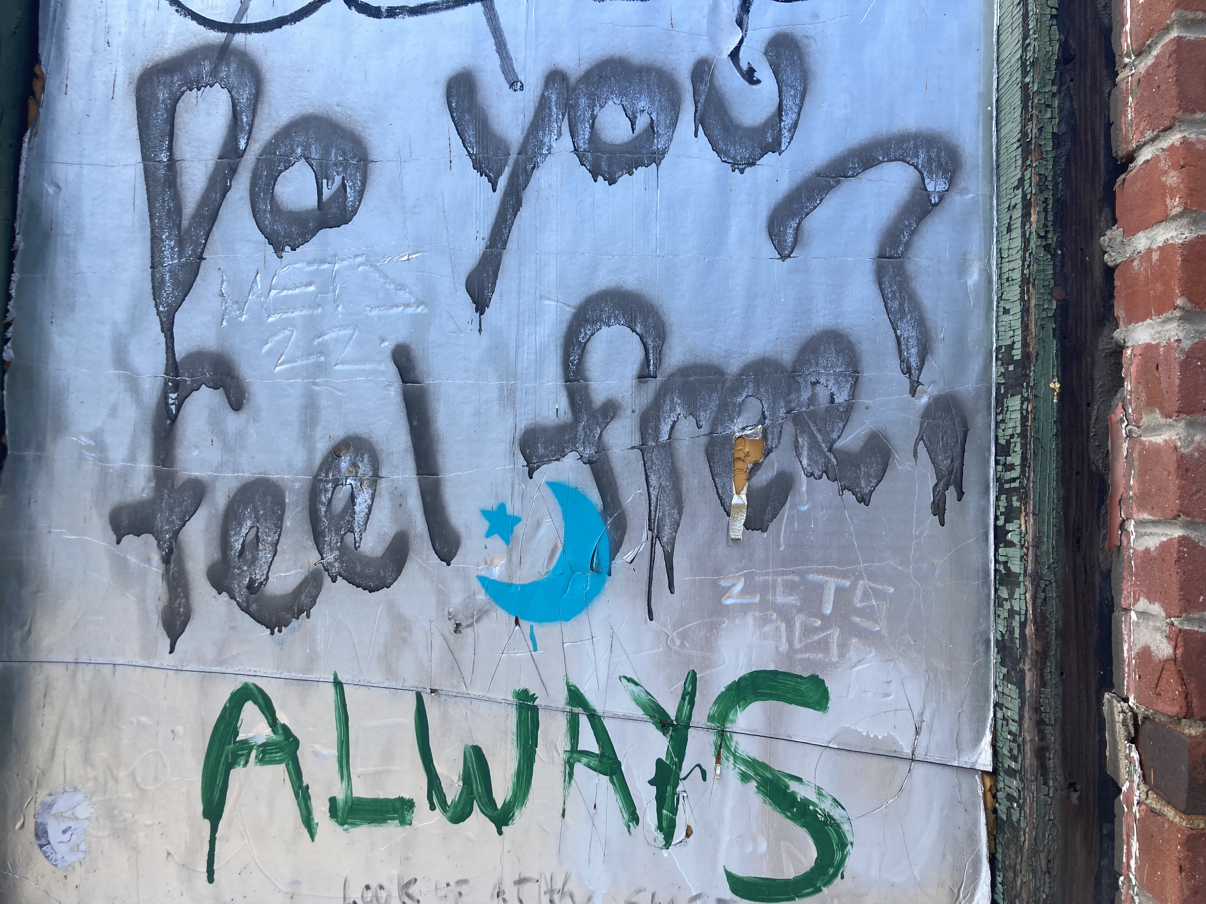

SEDER PLATE
Work in pairs to present the items on the Seder plate and to describe.

EGG: Because the springtime is a time of rebirth, when we can bring new possibility, new freedom, into our lives this egg is here. Eat an egg.

matzah: Why do we eat this flat, unleavened matzah? Because the decision to act came upon our forebears so quickly that their dough had not yet risen when You, the Breath of Life, bore them to freedom through a hurricane of transformation.

Blessed are You, Breath of Life, who makes us holy by connecting us with all of life and has breathed into us the wisdom to transform this unleavened, pressed-down bread of the poor into the bread of liberation.

BAH-rOOch AH-tAH AH-dOH-nEYE EH-LOH-hAY-nOO MEH-LEHch HA-OH-LAHm AH-shEHr KEEd-shAH-nOO BEH-mEEtz-vOH-tAHv VEH-tzEE-vAH-nOO AHL AH-chEE-LAHt MAH-tzAH. Eat matzah.

BITTER HERBS: These bitter herbs we eat, what is the reason for them? Because being forced into tight and narrow places cramps the abundance and creativity of all of life and makes life bitter.

Blessed are You, Breathing Spirit of the Universe, who makes us holy by connecting us to the eating of herbs so bitter they take away our breath.

BAH-rOOch AH-tAH AH-dOH-nEYE EH-LOH-hAY-nOO MEH-LEHch HA-OH-LAHm AH-shEHr KEEd-shAH-nOO BEH-mEEtz-vOH-tAHv VEH-tzEE-vAH-nOO AHL AH-chEE-LAHt MAH-rOHr.

CHAROSET: Charoset embodies the Song of Songs, bringing nuts and raisins, apricots and apples, spice and juices, into a joyful celebration of the earth and springtime and each other.

Create and eat the HILLEL SANDWICH with two pieces of matzah,
bitter herbs and charoset. Eat it.

We combine the maror, the bitter herb, in sweet charoset as a sign of hope, for we withstood the bitterness of slavery because it was sweetened by the hope of freedom. This symbolizes the need to take the good with the bad, to acknowledge the suffering alongside the redemption.

Why an olive?

Our Seder plate has an olive. Why an olive?
The olive tree, a universal symbol of peace has been the object of conflict in the Arab-Israeli conflict. The uprooting of the ancient olive trees, as a by-product of war, has had tremendous affects on the Palestinian agriculture, economy, and identity.
Because, for slavery to be truly over, for a people to be truly free,
we must know that we can feed ourselves and our children, today,
tomorrow, and into the following generations. In the lands of Israel and Palestine, olive groves provide this security. When olive groves are destroyed, the past and future is destroyed. Without economic security, a people can much more easily be conquered or enslaved.
And so this year, we eat an olive, to make real our understanding
of what it means each time a bulldozer plows up a grove. Without the taste of olives, there will be no taste of freedom.
Give an olive to everyone.

As one, we toast with an olive, saying: From the river to the sea, everyone will be free.

AN ORANGE: TAPUZ

The orange is on the seder plate to symbolize the desire to include people who are left out – lesbians, gays, transgenders, and women – present, but marginalized and pushed from leadership.

On a night devoted to liberation and escape from oppression, we should honor the orange for it reminds us to stand up for those who are regarded as other and demand the full and equal participation of everyone in the global movement toward redemption. Hatred and ignorance do not belong on the way toward a sustainable and compassionate future.

Each guest is sprayed with the fragrance from the orange peel.
The smell and color of orange also signifies abundance. --- Eat soup.

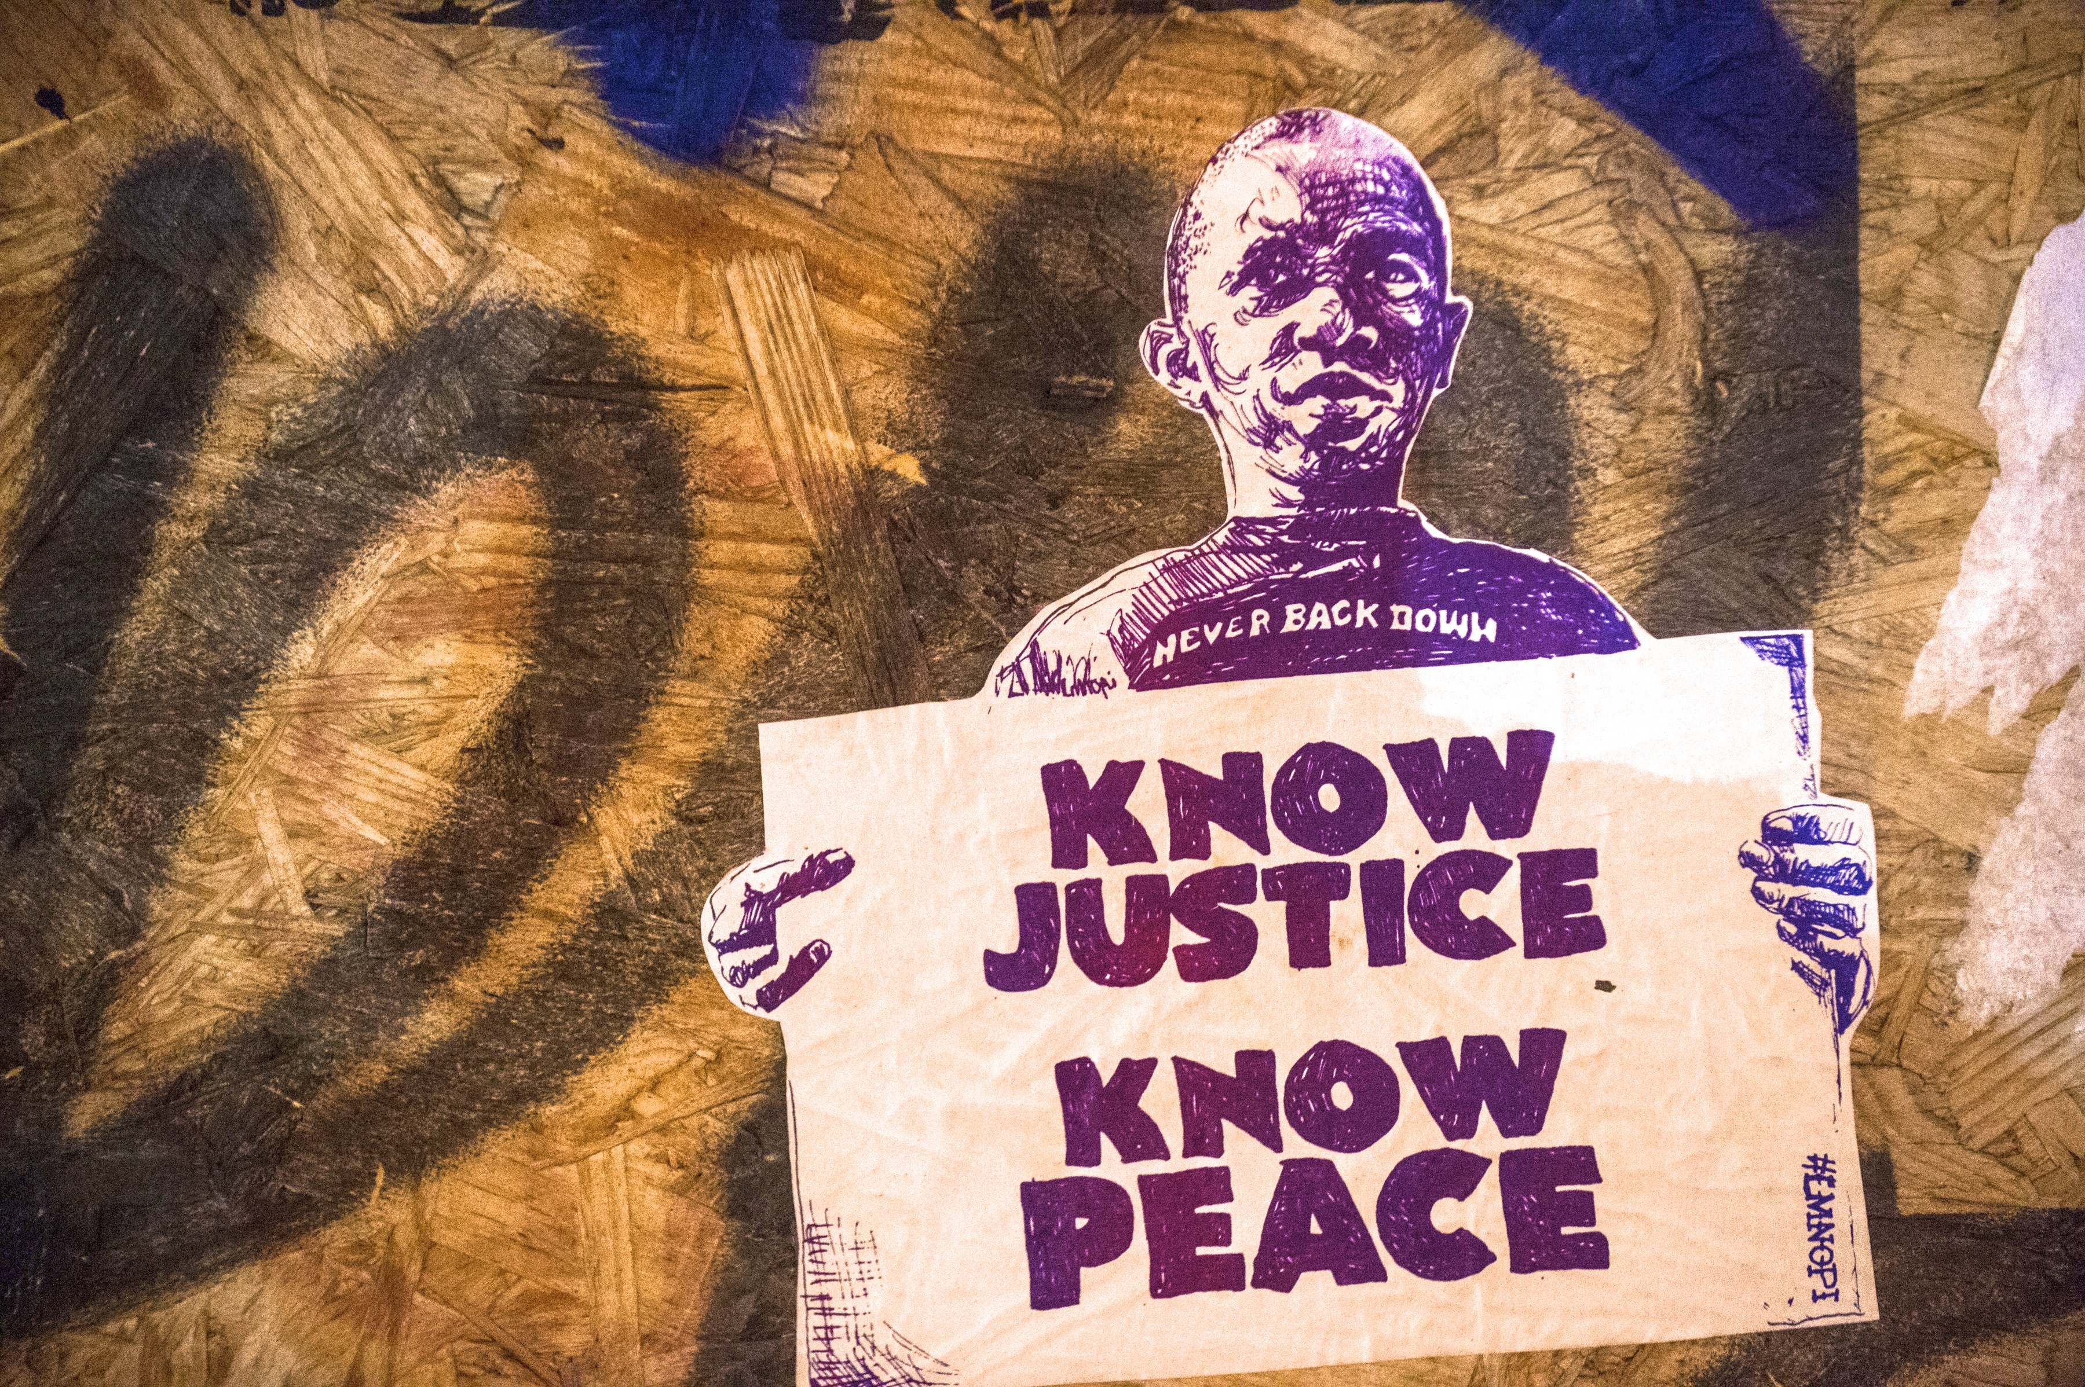

Cup #2 / A WORD FROM ABRAHAM LINCOLN

1864, a year before Abraham Lincoln was murdered, he is reported to have written in a letter the following statement: “Corporations have been enthroned and an era of corruption in high places will follow, and the money power of the country will endeavor to prolong its reign by working upon the prejudices of the people until all the wealth is aggregated in a few hands and the Republic is destroyed.”

Let us raise our glass and drink to the end of corporate rule on Earth.
Down with Big Business.

Make eye contact with everyone then drink. Prepare the show.

If we are to get on the right side of the world revolution, we as a nation must undergo a radical revolution of values. We must rapidly begin the shift from a “thing-oriented” society to a “person-oriented” society. When machines and computers, profit motives and property rights are considered more important than people; the giant triplets of racism, militarism, and economic exploitation, are incapable of being conquered. A true revolution of values will soon cause us to question the fairness and justice of many of our present policies. … Our only hope today lies in our ability to recapture the revolutionary spirit and go out into a hostile world declaring eternal hostility to poverty, racism and militarism.
- Dr. Martin Luther King, April 4, 1967

Freedom is not something that anybody can be given. Freedom is something people take, and people are as free as they want to be. ― James Baldwin

I’ll tell you what Freedom is to me. No fear. – Nina Simone

Play Sam Cooke’s recording of “Blowin’ in the Wind”.

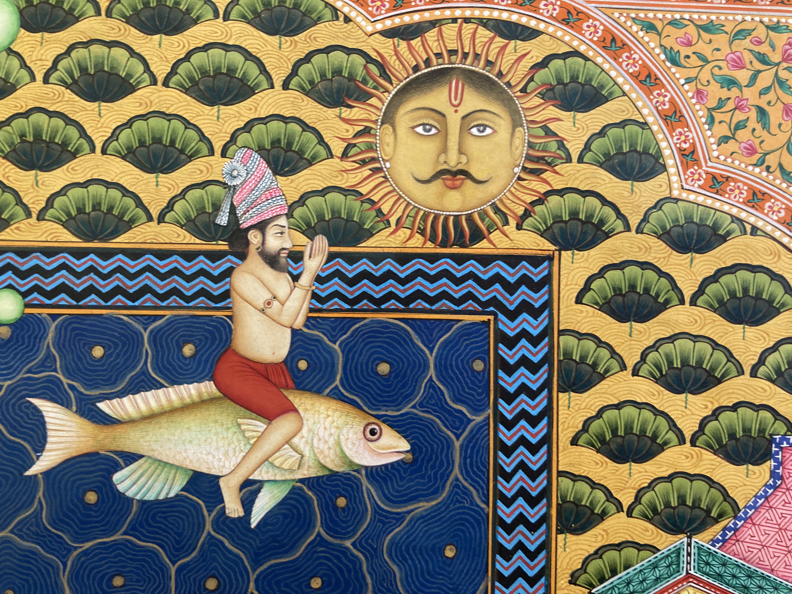

Detail of A. Gorlizki
Moses in Five Acts
a play to share for Passover
by Rebbe Wally
The play can be performed by four young people (A, B, C and D).
CHARACTERS
Pharaoh (A)
Storyteller (B)
The Mother
Baby (non-speaking)
Miriam (D)
Princess (A)
Moses
Aaron (D)
Slave Masters (adults)
Slaves (adults)
Former Slave (A)

Prop LIsT:
The Pharaoh’s announcement sign, a basket for the baby, scallions for whips

PROLOGUE
Play Tiken Jah Fakoly’s “Slavery Days”. The Pharaoh puts up a sign that reads: “PHARAOH’S LAW: Death to your first-born son. Starting now.”

ACT ONE – A MOTHER’S COURAGE
Storyteller: Many, many moons ago, a mother sends her baby boy down the river in order to save him because she was caught between life and the Pharaoh’s law. She builds a small ark and sends him to an uncertain future.
The Mother weeps by the riverside then makes a solemn wish.
Mother: Oh river, carry my son safely so he may grow in a land that is free.
Participants slowly pass around a basket with the smallest child or doll in it while whispering words of encouragement and singing “Swing Low”.
Chorus: Swing low, sweet chariot
Coming for to carry me home,
Swing low, sweet chariot,
Coming for to carry me home.
I looked over Egypt, and what did I see
Coming for to carry me home?
A band of angels coming after me,
Coming for to carry me home.
Repeat chorus.

ACT TWO – PHARAOH’S DAUGHTER
Princess, the Pharaoh’s daughter, goes to the river and swims.
Storyteller: The next morning, miles and miles away, Princess, the Pharaoh’s daughter, was swimming in a river with her friend Miriam who was from a different class and race. Together they transcend the boundaries of society, envisioning something new. As the sun starts to sparkle on the water the two friends see something floating peacefully down the river.
Miriam: Hello duck.
Princess: Hello baby.
Miriam: You’re as calm as the water.
Princess: We’ll name you Moses. You are welcome into our life Moses.
Miriam: Thanks for coming.
Moses enters.
Storyteller: Miriam and the Princess raise Moses so he would know the truth of his relationship with the river that delivered him. Moses grows up in the flow.
Moses: I am in this world by the grace of three mothers, the mother who gave birth to me, the mother that fished me out of the river and Mother Nature herself.

ACT THREE - MOSES GROWS UP
Storyteller: Moses and his Jewish brother Aaron grow up working as slaves.
Song: Chain Gang by Sam Cooke.
Slaves go to work and are repeatedly beaten by Slave Masters with scallions.
Slave Masters: (repeated) Keep working! Keep working!!
Slaves: (repeated) Oy! Oy!! Oy! Oy!!
Storyteller: One day Moses murdered a Slave Master that was hurting a worker badly.
Moses murders a Slave Master.
Moses: Oh what a mistake! I should be non-violent at all times. Oh the sad and fearful slave master. Peace can only come after empathy.

ACT FOUR – GETTING THROUGH TO PHARAOH
Aaron and Moses go to see Pharaoh
Storyteller: Moses and his brother Aaron go to Pharaoh and try to persuade him to let the slaves be free.
Aaron: Be reasonable Pharaoh.
Moses: Be kind.
Pharaoh: No!
Aaron: Come on!
Moses: Let my people go!
Pharaoh: I said, No.
Storyteller: Because Pharaoh doesn’t budge the Universe conspires to assist with Moses’ one big wish. Ten plagues visit Egypt.
ALL: To sacrifice some of our pleasure in honor of the real plagues of our Earth, lets take out a drop of wine from our cup for each plague.
Everyone around the table places ten drops of wine on their plates as they say the Ten Plagues. The ensemble act out each of the plagues. Play “Go Down Moses”.
1. Da-am / Blood / Pollution and privatization of water
2. Tz’far-dei-ah / Frogs / Amphibians dead and maimed by chemicals
3. Kee-neem / Lice / Poverty
4. Ah-rov / Swarms / Extinction of thousands of species
5. Deh-ver / Pestilence / Factory Farms
6. Sh-cheen / Boils / Collapse of health care
7. Ba-rad / Hail / Radical climate crisis
8. Ar-beh / Locusts / Famine
9. Cho-shech / Darkness
10. Ma-kat B’cho-rot / Death of the Firstborn / War & violence
Storyteller: Only after everyone’s first-born son dies does Pharaoh change his mind.
Moses: How about now?
Pharaoh: Go! Get out of here!

ACT FIVE – EXODUS
Storyteller: The Pharaoh’s bullies and thugs harassed and tortured the slaves as they left. They pursued them all the way to the Red Sea.
Moses, Aaron, Miriam and the Slaves come to the Red Sea.
Aaron: To Moses Now what are we going to do? To everyone. What can we do now?!
Slaves: We can’t go back.
Moses: Inspired. Fear not friends, look forward. In your thoughts say to the sea, “The sea is receding, thank you for doing that.” Repeat it.
Everyone repeats, “The sea is receding, thank you for doing that.”
Aaron: The water is going down, lets go everyone!
Storyteller: As soon as they were safe the red sea swelled again washing all of the Pharaoh’s soldiers away. Miriam led the women and the rest in a joyful celebration.
Dance break. Stevie Wonder’s “Sir Duke”.
Pour Miriam’s Cup, a cup of water because waters birth new possibility. Refill water glasses.

Storyteller: Miriam led the women in rejoicing as the Red Sea waters broke and made their escape final. In the desert Miriam called forth the well of water that nourished the runaway slaves. Now, in honor of Miriam, we enjoy our water.

EPILOGUE
Storyteller: Over a million people wandered around the desert for a very long time.
Former Slave: We put the Oy back in unemployment.
Storyteller: During their psychedelic journey Moses spoke to a burning bush, he talked with spirits on top of a mountain and he came down from that mountain with Ten Commandments that he said everyone is supposed to live by.
Moses: To All. How many commandments can you name? How many do you live by?
Storyteller: Thanks for retelling the story of the exodus from Egypt. Welcome back to our present day. Now onward.

Applause. Bows.

WHY DID GOD CREATE ATHEISTS?

In “Tales of Hasidim”, Martin Buber tells a story addressing why God created atheists. It is considered one of the more famous stories of Chassidic literature.

A Rabbi is teaching his student the Talmud and explains God created everything in this world to be appreciated, since everything is here to teach us a lesson. The clever student asks “What lesson can we learn from atheists? Why did God create them?”

The Rabbi responds “God created atheists to teach us the most important lesson of them all – the lesson of true compassion. You see, when an atheist performs an act of charity, visits someone who is sick, helps someone who is in need, and cares for the world, he is not doing so because of some religious teaching. He does not believe that God commanded him to perform this act. In fact, he does not believe in God at all, so his acts are based on an inner sense of morality. And look at the kindness he can bestow upon others simply because he feels it to be right.”

“This means” the Rabbi continued “that when someone reaches out to you for help, you should never say ‘I pray that god will help you.’ instead for the moment, you should become an atheist, imagine that there is no god who can help, and say ‘I will help you.'”

MORE QUESTIONS

Now that we have enacted the story of the slaves from Egypt, what questions do we have?

Tonight we ask questions that lead to more questions.

What fears are we enslaved by? Listen.
Does faith in God enable freedom or enslavement? Listen.
What is spirituality? Listen.
Does the Universe really conspire in our favor? Listen.
Do you believe in miracles? Listen.

Take time to listen to all questions and respond.

Enjoy dinner. Continue Haggadah after dinner is cleared.
FOUR CHILDREN

At Passover, we are confronted with the stories of our ancestors’ pursuit of liberation from oppression. Facing this mirror of history, how do we answer their challenge? How do we answer our children when they ask us how to pursue justice in our time?

What does the Activist Child ask? “Torah tells me, ‘Justice shall you pursue,’ but how can I pursue justice?”
Empower her always to seek pathways to advocate for the vulnerable. As Proverbs says, “Speak up for the mute, for the rights of the unfortunate. Speak up, judge righteously and champion the poor and the needy.”

What does the Skeptical Child ask? “How can I solve problems of such enormity?”
Encourage her by explaining that she need not solve the problems, she must only do what she is capable of doing. It is not your responsibility to complete the work, but neither are you free to not help at all.

What does the Indifferent Child say? “It’s not my responsibility.”
Persuade him that responsibility cannot be shirked. As Abraham Joshua Heschel writes, “The opposite of good is not evil, the opposite of good is indifference. In a free society where terrible wrongs exist, some are guilty, but all are responsible.” Apathy kills.

And the Uninformed Child who does not know how to ask…
Prompt her to see herself as an inheritor of our people’s legacy. As it says in Deuteronomy, “You must befriend the stranger, for you were strangers in the land of Egypt.”
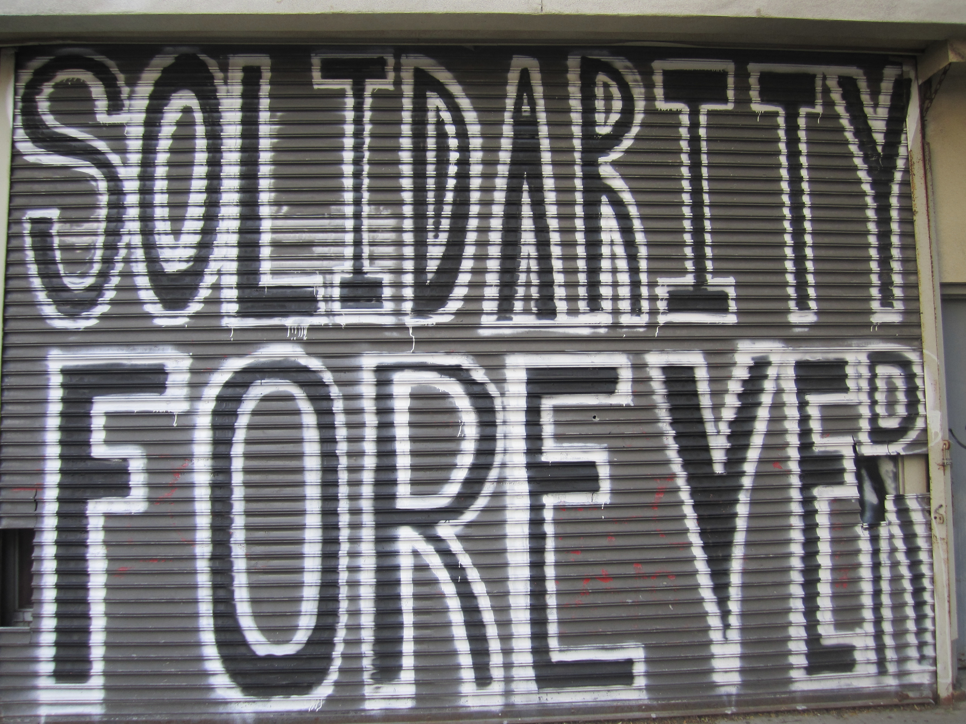

CUP #3

We raise our glass with the pledge that we will always imagine and seek alternative ways to bring about the liberation of all on Earth – by any means necessary.
Play Malcolm X, “… by any means necessary.”
Make eye contact with each and everyone then drink.
Play David Krakauer’s “The Streets of Klezmer, NY”.

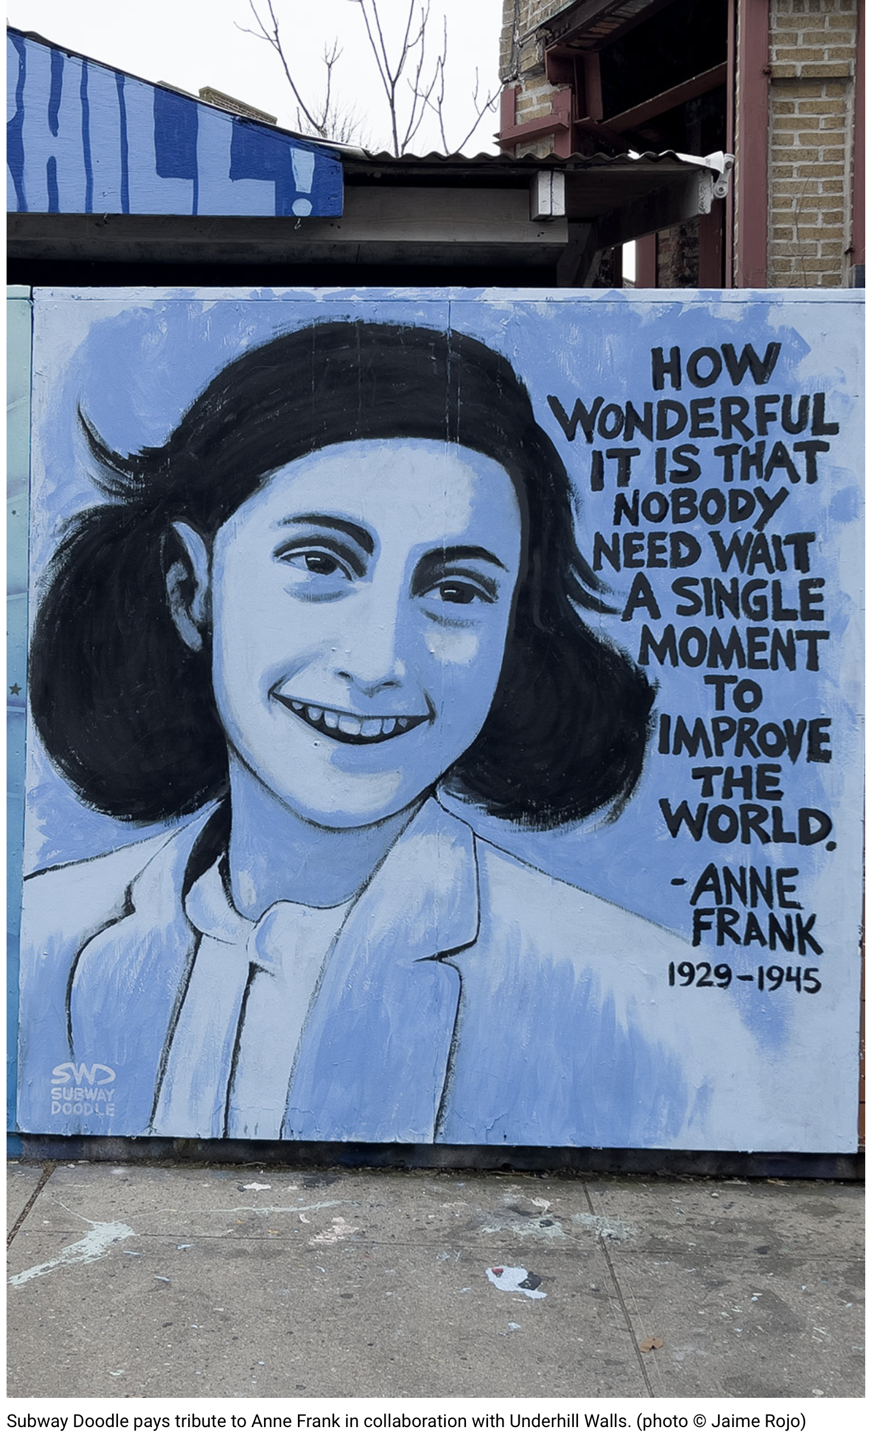

ANNE FRANK: I STILL BELIEVE

That’s the difficulty in these times: ideals, dreams, and cherished hopes rise within us, only to meet the horrible truth and be shattered. It’s really a wonder that I haven’t dropped all my ideals because they seem so absurd and impossible to carry out. Yet I keep them, because in spite of everything I still believe that people are really good at heart. I simply can’t build up my hopes on a foundation consisting of confusion, misery, and death. I see the world gradually being turned into a wilderness. I hear the ever-approaching thunder, which will destroy us, too. I can feel the suffering of millions – and yet, if I look up into the heavens, I think it will come out all right, that this cruelty too will end, and that peace and tranquility will return again.
In the meantime, I must uphold my ideals, for perhaps the time will come when I shall be able to carry them out.
(Diary of Anne Frank, Amsterdam 1944)
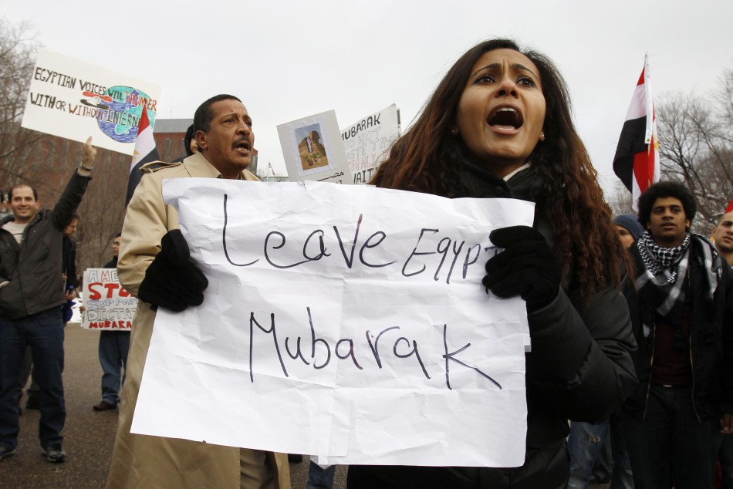

2011 EGYPTIAN REVOLUTION and ASMAA MAHFOUZ
Asmaa Mahfouz (born February 1, 1985) is a member of Egypt’s Coalition of the Youth of the Revolution and one of the founders of the April 6 Youth Movement. She has been credited with helping to spark mass uprising through her video blog posted one week before the start of the eighteen-day 2011 Egyptian revolution. Here are quotes from those videos:

Asmaa Mahfouz’s January 18, 2011 post

If you think yourself a man, come with me on January 25th. Whoever says women shouldn’t go to protests because they will get beaten, let him have some honor and manhood and come with me on January 25th. Whoever says it is not worth it because there will only be a handful of people, I want to tell him, “You are the reason behind this, and you are a traitor, just like the president or any security cop who beats us in the streets.” Your presence with us will make a difference, a big difference. Talk to your neighbors, your colleagues, friends and family, and tell them to come. They don’t have to come to Tahrir Square. Just go down anywhere and say it, that we are free human beings. Sitting at home and just following us on news or Facebook leads to our humiliation, leads to my own humiliation. …

Go down to the street. Send texts. Post it on the net. Make people aware. You know your own social circle, your building, your family, your friends. Tell them to come with us. Bring five people or ten people. If each one of us manages to bring five or ten to Tahrir Square and talk to people and tell them, “This is enough. Instead of setting ourselves on fire, let us do something positive,” it will make a difference, a big difference.

Never say there’s no hope. Hope disappears only when you say there’s none. So long as you come down with us, there will be hope. Don’t be afraid of the government. Fear none but God. God says He will not change the condition of a people until they change what is in themselves. Don’t think you can be safe anymore. None of us are. Come down with us and demand your rights, my rights, your family’s rights. I am going down on January 25th, and I will say no to corruption, no to this regime.

MIRIAM AND ELIJAH

Miriam is beginning; Elijah is end. Miriam is present; Elijah is future. Miriam is place; Elijah is time. Elijah is the mountain; Miriam is the sea. The water of Miriam rises from the earth; the fire of Elijah descends from the sky. Together they are the circle of sunlight and rain, not separate or dissimilar, for both are needed for growth. We must have consciousness of both in order to be free.

welcome elijah
Open the door and let the spirit Elijah in and pour him a cup of wine.

Hurry, reconcile the heart, redeem us from
dissonance, gather us in from the exile of argument,
from earthly fracture to eternity, bring us to the
threshold, speedily, revive our mysteries, witness our
desire, ascending, solitary prophet in
a chariot of fire.

Eliyahu HaNavi, Elijah the Prophet is a song entreating the prophet Elijah, an invited guest at Passover, to return soon with the Messiah.

Eliyahu haNavi  Eliyahu haTishbi,  Eliyahu haGil’adi –  Bim’hera v’yameinu yavoh eleinu,  im mashiach ben David. X2 | Elijah the prophet  Elijah the Tishbite,  Elijah the Giladite –  In haste and in our days may he come to us with the messiah son of David. X2

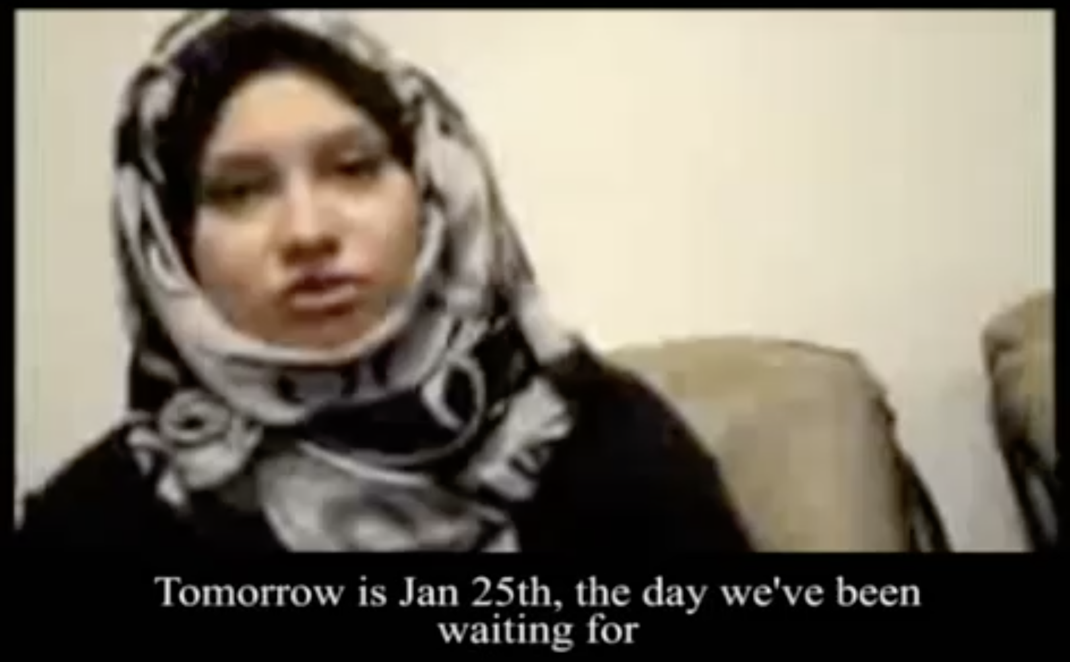

Asmaa’s January 24, 2011 post, the eve of the protest

It’s now 10:30 p.m. on January 24th, 2011. Tomorrow is the 25th, the day we’ve been waiting for, the day we all worked so hard for. The most beautiful thing about it is that those who worked on this were not politicians at all. It was all of us, all Egyptians. We worked hard. Children no older than 14, they printed the poster and started distributing it after prayers.
Old people in their sixties and seventies helped as well. People distributed it everywhere they could—in taxis, at the metro, in the street, in schools, universities, companies, and government agencies. All of Egypt awaits tomorrow.

I know we are all nervous right now and anxious, but we all want to see tomorrow’s event happen and succeed. I’d like to tell everyone that tomorrow is not the revolution and is not the day we’ll change it all. No, tomorrow is the beginning of the end.

Tomorrow, if we make our stand despite all the security may do to us and stand as one in peaceful protest, it will be the first real step on the road to change, the first real step that will take us forward and teach us a lot of things. Our solidarity in planning is a success in itself. To simply know that we must demand our rights, that is success.

Get Out of Egypt
by Wally

Sometimes it feels like we’re slaves in secret
All work and no play, should we get out of Egypt?
We can’t live anymore on the straight and narrow
Could we open the door and say, “No more,” to Pharaoh?

Get out, get out, get out, get out
No more, no more, no more, no more

Say, “No more,” to Pharaoh and Get out of Egypt

How can we act while riddled with fear?
Where’s truth? What’s fact? O get fear out of here
In myself and my kin this freedom seed’s been planted
Grab hands and begin just take no more for granted

Get out, get out, get out, get out
No more, no more, no more, no more
Take no more for granted

Get fear out of here

Say, “No more,” to Pharaoh and Get out of Egypt

Pharaoh’s only rule is to stay in his tower
Use the People like tools till we find our own power
We want Life to have less stress and violence
We’ll be on our way when there’s no more silence

Get out, get out, get out, get out
No more, no more, no more, no more
No more silence

Find our own power
Take no more for granted

Get fear out of here

“No more,” to Pharaoh and
“Get out of Egypt”

Rebellion whispers through the years, do you hear it?
“Love’s more precious than gold go invest our spirit
There’s enough to share, we have what we need
Kindness and care, not corporate greed

Get out, get out, get out, get out
No more, no more, no more, no more
No corporate greed
Invest our spirit
No more silence

Find our own power
Take no more for granted

Get fear out of here

Say, “No more,” to Pharaoh and
“Get out of Egypt”

How’s about a future with peace and respect?
Sharin’ joy with Mother Earth and the Universe that’s perfect
We can’t take any more of the Pharoah’s war order
After seven thousand years, how ‘bout no more borders?

Get out, get out, get out, get out
No more, no more, no more, no more
Say no more borders
The Universe is perfect
No corporate greed
Invest our spirit
No more silence

Find our own power
Take no more for granted

Get fear out of here

Say, “No more,” to Pharaoh

Say, “No more,” to Pharaoh
and Get out of Egypt go on and
Get out of Egypt we got to
GET OUT OF EGYPT

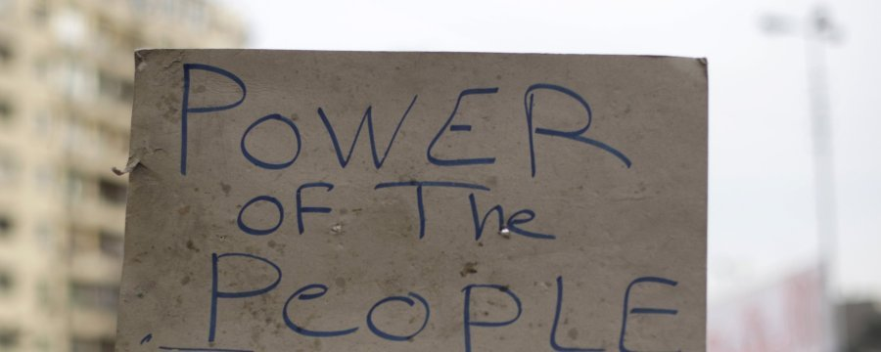
Asmaa’s January 26 post, the day after the protest

The people want to bring down the regime. This is what we were all chanting yesterday, January 25th, 2011. Thousands upon thousands — I could not count how many there were. Demonstrations from all sides. Riot police could not control the sheer numbers.

What we learned yesterday is that power belongs to the people, not to the thugs. Power is in unity, not in division. Yesterday, we truly lived the best moments of our lives. We learned that the Egyptian people are not chaotic or disorderly. The government keeps saying that we are a chaotic people and a revolution will lead to chaos. Yesterday, we were truly one hand, concerned for one another. Yesterday, not even one girl was harassed, even among those thousands. No one stole anything. No one struck anyone. No fights broke out. We were defending each other. Everyone was concerned for one another. Some bought water bottles and distributed them; others distributed sandwiches. We all said it was from our hearts. Long live Egypt! Some boys and girls even cleaned the streets of trash and garbage. This is the Egyptian people that we have always dreamed of. I can now say that I am proud to be Egyptian. I truly wish to kiss every Egyptian’s forehead and say, “Thank you for being Egyptian.” I never imagined that I would see this.

On February 11, 2011 Pharaoh Hosni Muburak gave up power after eighteen days of protest. At this time, on the eve of Passover 2024, Egypt has silenced the protest movement and still has the military’s authoritarian President Abdel-Fattah al-Sisi who took power in 2013.
Breathe. Reflect.
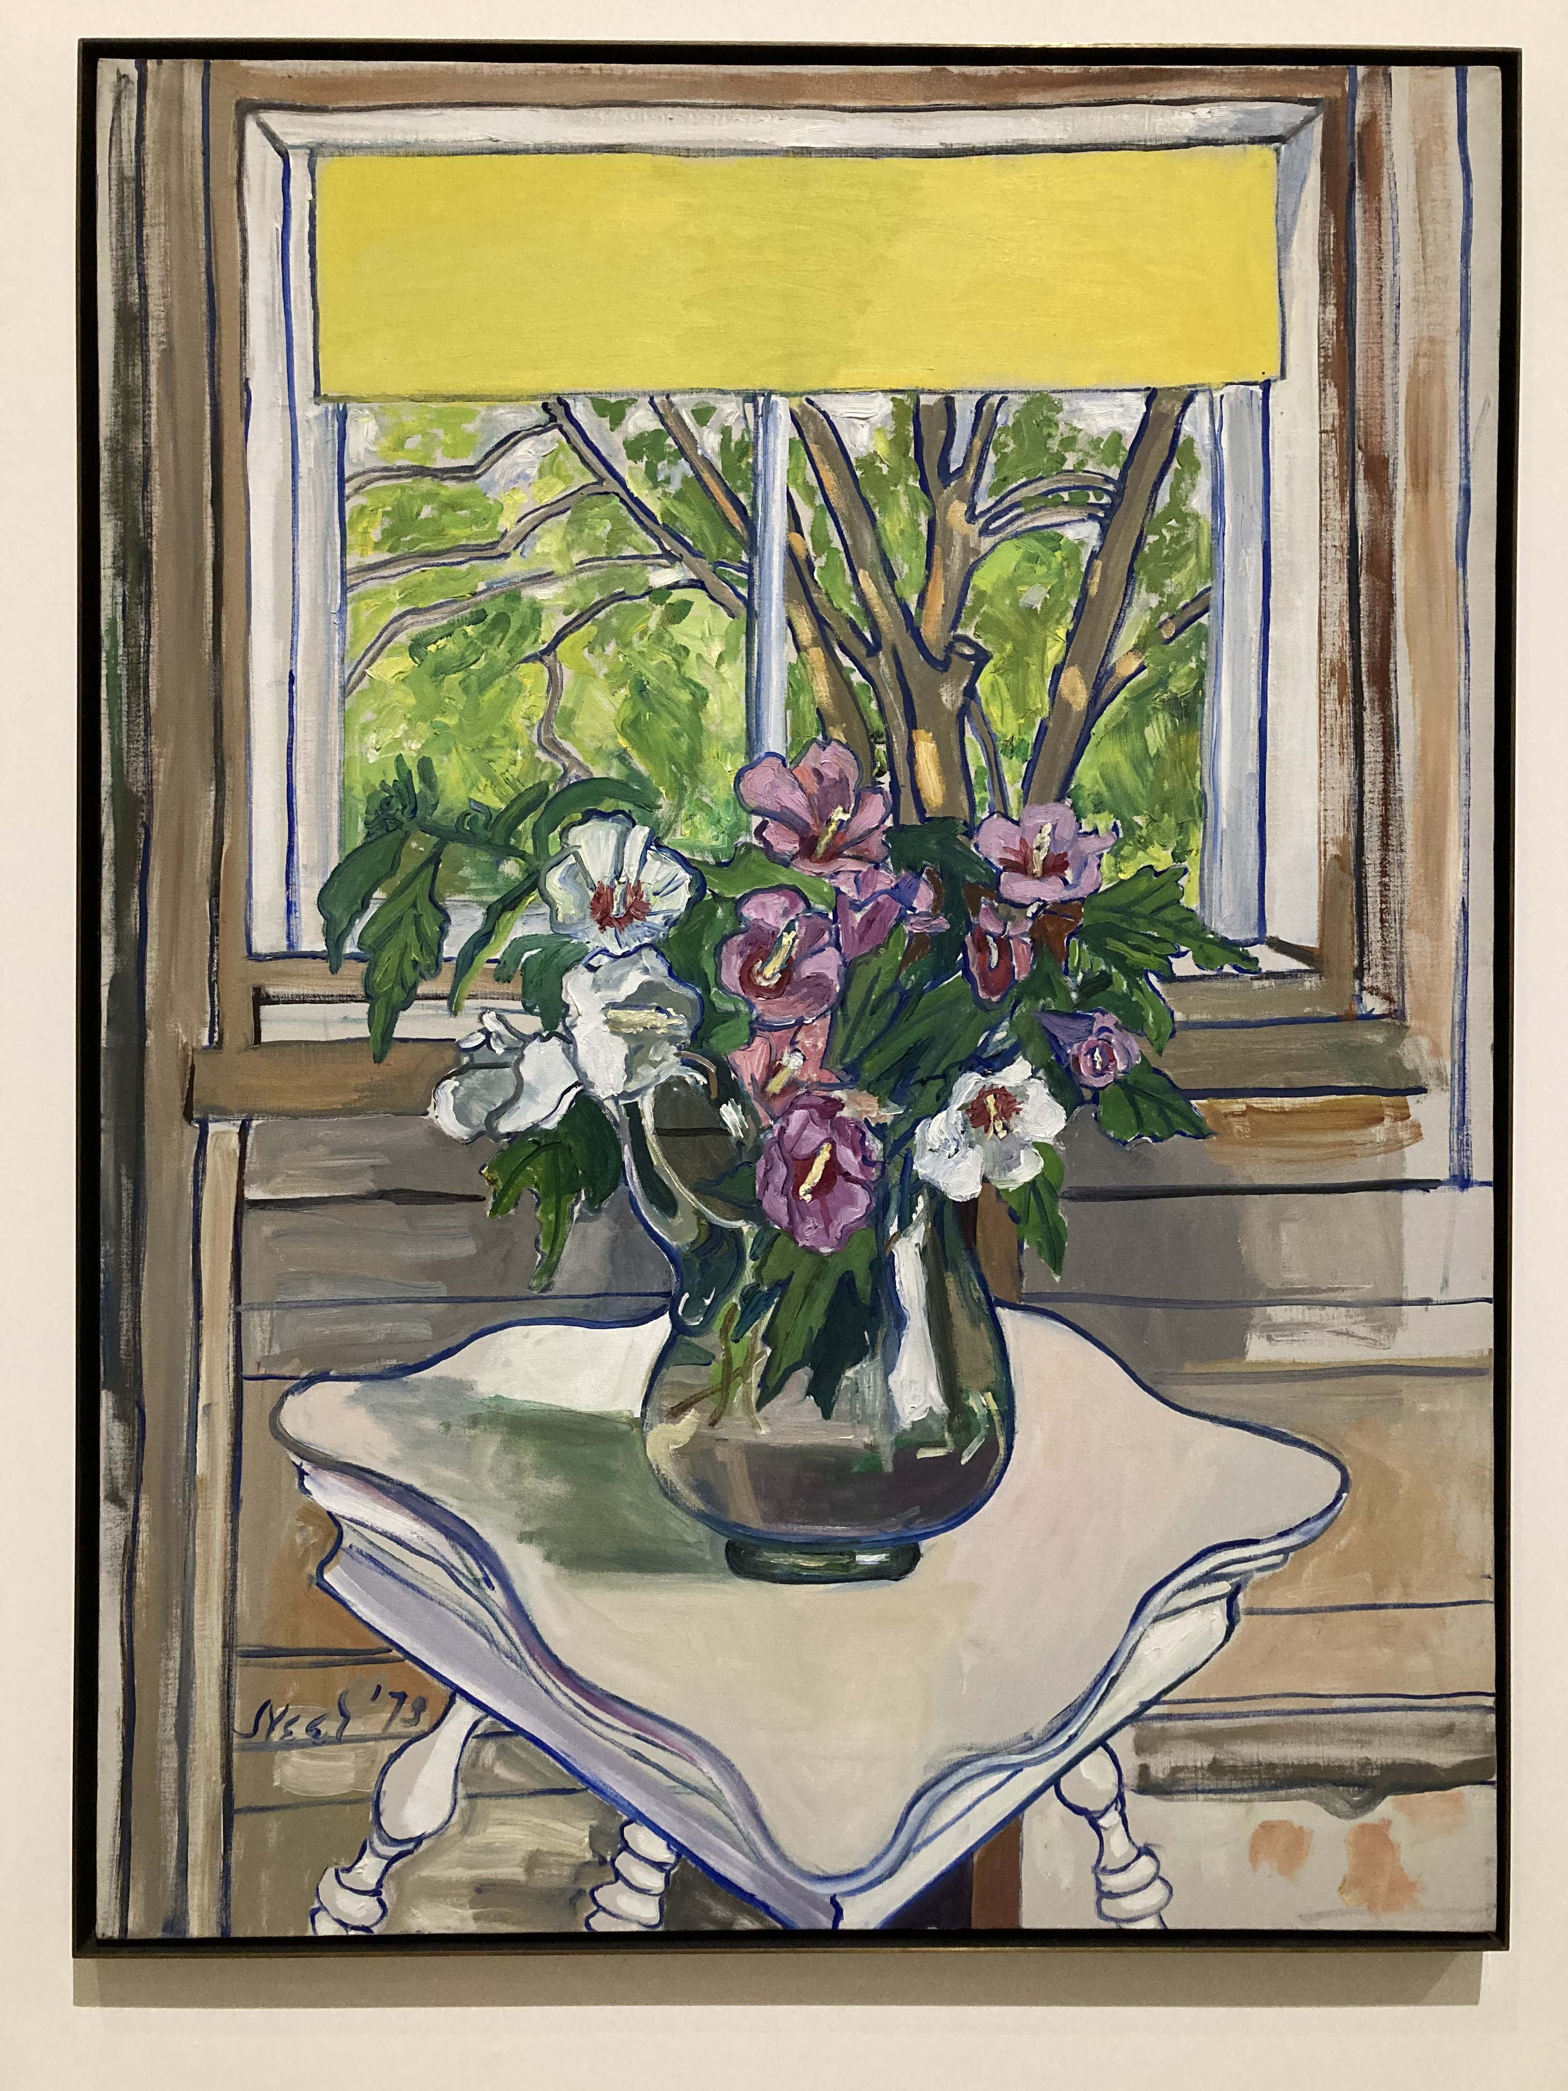 By Alice Neel
CUP #4
We are aware enough to know and understand our dark times. As we reconnect with the past, our roots, can we devise a plan or help in some way to the coming of a new age of equality, justice and peace? What can we do? With this glass we accept personal and communal responsibility to act. To beginning again.
Make eye contact with each and everyone then drink.

WHAT IS YOUR CONTRIBUTION? WHAT WILL YOU DO? Listen.

AFIKOMAN FOUND
At this time, we are invited to hunt for the Afikoman. When it is found those who found it hold it up as high as possible.

With love and gratitude, we close the circle of our seder tonight by raising the glass one more time as we say,
Everyone raises their glass.
Lo! This is the bread of poverty that our ancestors ate.
Let all who are hungry come and eat!
Let all who are in need share in the hope of Passover!
This year we all are slaves,
Next year may we all be free.
Tonight, to redeem the Afikoman:
We renew our commitment to help all who are hungry round the world,
So that next year we may all be free.
L’chaim!

Make eye contact with each and everyone then drink.

Join hands and listen to everyone’s REFLECTION and/or NEW INTENTION.

The seder officially concludes with, gratitude and love, love, love.

The Afikoman is distributed to everyone. Jewelry is returned.

POETRY and MUSIC FREE FOR ALL!

TOMORROW from Annie by Charles Strouse and Martin Charnin
The sun’ll come out tomorrow
Bet your bottom dollar
That tomorrow there’ll be sun
Just thinkin’ about tomorrow
Clears away the cobwebs,
And the sorrow ‘til there’s none
When I’m stuck a day
That’s gray and lonely,
I just stick out my chin
and grin and say, Oh!
The sun'll come out tomorrow
So ya gotta hang on til tomorrow
Come what may
Tomorrow! Tomorrow!
I love ya Tomorrow!
You’re always
a day away! X2

Dona Dona by Aaron Zeitlin and Shalom Secunda

On a wagon bound for market
There’s a calf with a mournful eye.
High above him there’s a swallow
Winging swiftly through the sky.

(Chorus) How the winds are laughing
They laugh with all their might
Laugh and laugh the whole day through
And half the summer’s night.
Dona dona dona dona x4

“Stop complaining,” said the farmer,
“Who told you a calf to be
Why don’t you have wings to fly away
Like the swallow so proud and free?”
(Chorus)
Calves are easily bound and slaughtered
Never knowing the reason why.
But whoever treasures freedom,
Like the swallow must learn to fly.
(Chorus)

IF I HAD A HAMMER by Trini Lopez

If I had a hammer
I’d hammer in the morning
I’d hammer in the evening
All over this land

I’d hammer out danger
I’d hammer out a warning
I’d hammer about the love between my brothers and my sisters
All, all over this land

Ooh, ooh ooh, Ooh, ooh ooh, Ooh, ooh

If I had a bell
I’d ring it in the morning
I’d ring it in the evening
All over this land

I’d ring out danger
I’d ring out a warning
I’d ring about the love between my brothers and my sisters
All, all over this land

Ooh, ooh ooh, Ooh, ooh ooh, Ooh, ooh

If I had a song
I’d sing it in the morning
I’d sing it in the evening
All over this land

I’d sing out danger
I’d sing out a warning, yeah
I’d sing out about the love between my brothers and my sisters
All, all over this land

Ooh, ooh ooh, Ooh, ooh

Now, I’ve got a hammer
And I’ve got a bell
And I’ve got a song to sing
All over this land

It’s the hammer of justice
It’s the bell of freedom, yeah
It’s the song about the love between my brothers and my sisters
All, all over this land

Yeah, yeah, yeah, yeah, yeah
Yeah, yeah, yeah, yeah
All over this land
Ooh, all over this land
Hee, all over this land, yeah, yeah, yeah, yeah
Yeah, yeah, yeah, yeah
All over this land
Hee, all over this land

KEY L’OLAM CHASDO

ADEER HOO

CHAD GADYA

THIS LAND IS YOUR LAND

“… What would it mean to live
in a city whose people were changing
each other's despair into hope? --
You yourself must change it. --
what would it feel like to know
your country was changing? --
You yourself must change it. --
Though your life felt arduous
new and unmapped and strange
what would it mean to stand on the first
page of the end of despair?”
- Adrienne Rich, 1983 from the poem Dreams Before Waking

------------------------

“I do not believe a Cause which stands for a beautiful ideal, for anarchism, for release and freedom from conventions and prejudice, should demand the denial of life and joy. … I want freedom, the right to self-expression, everybody’s right to beautiful, radiant things. … I don’t care if a person’s theory for tomorrow is correct, I care if their spirit of today is correct.”
- Emma Goldman

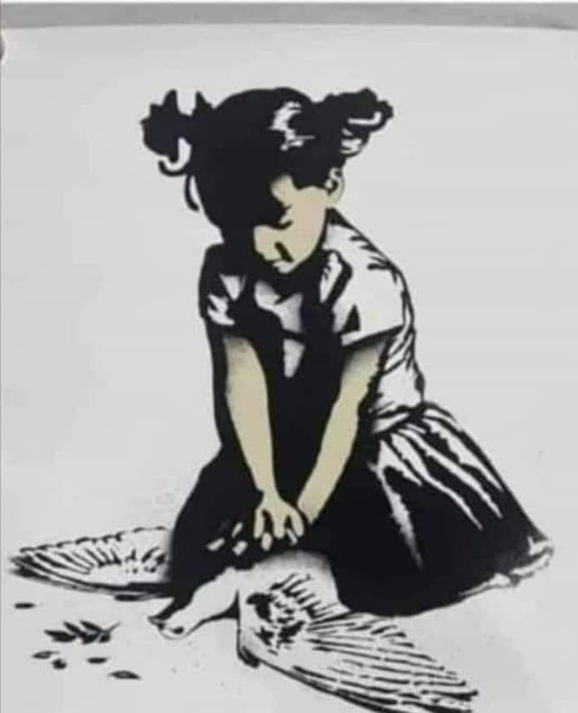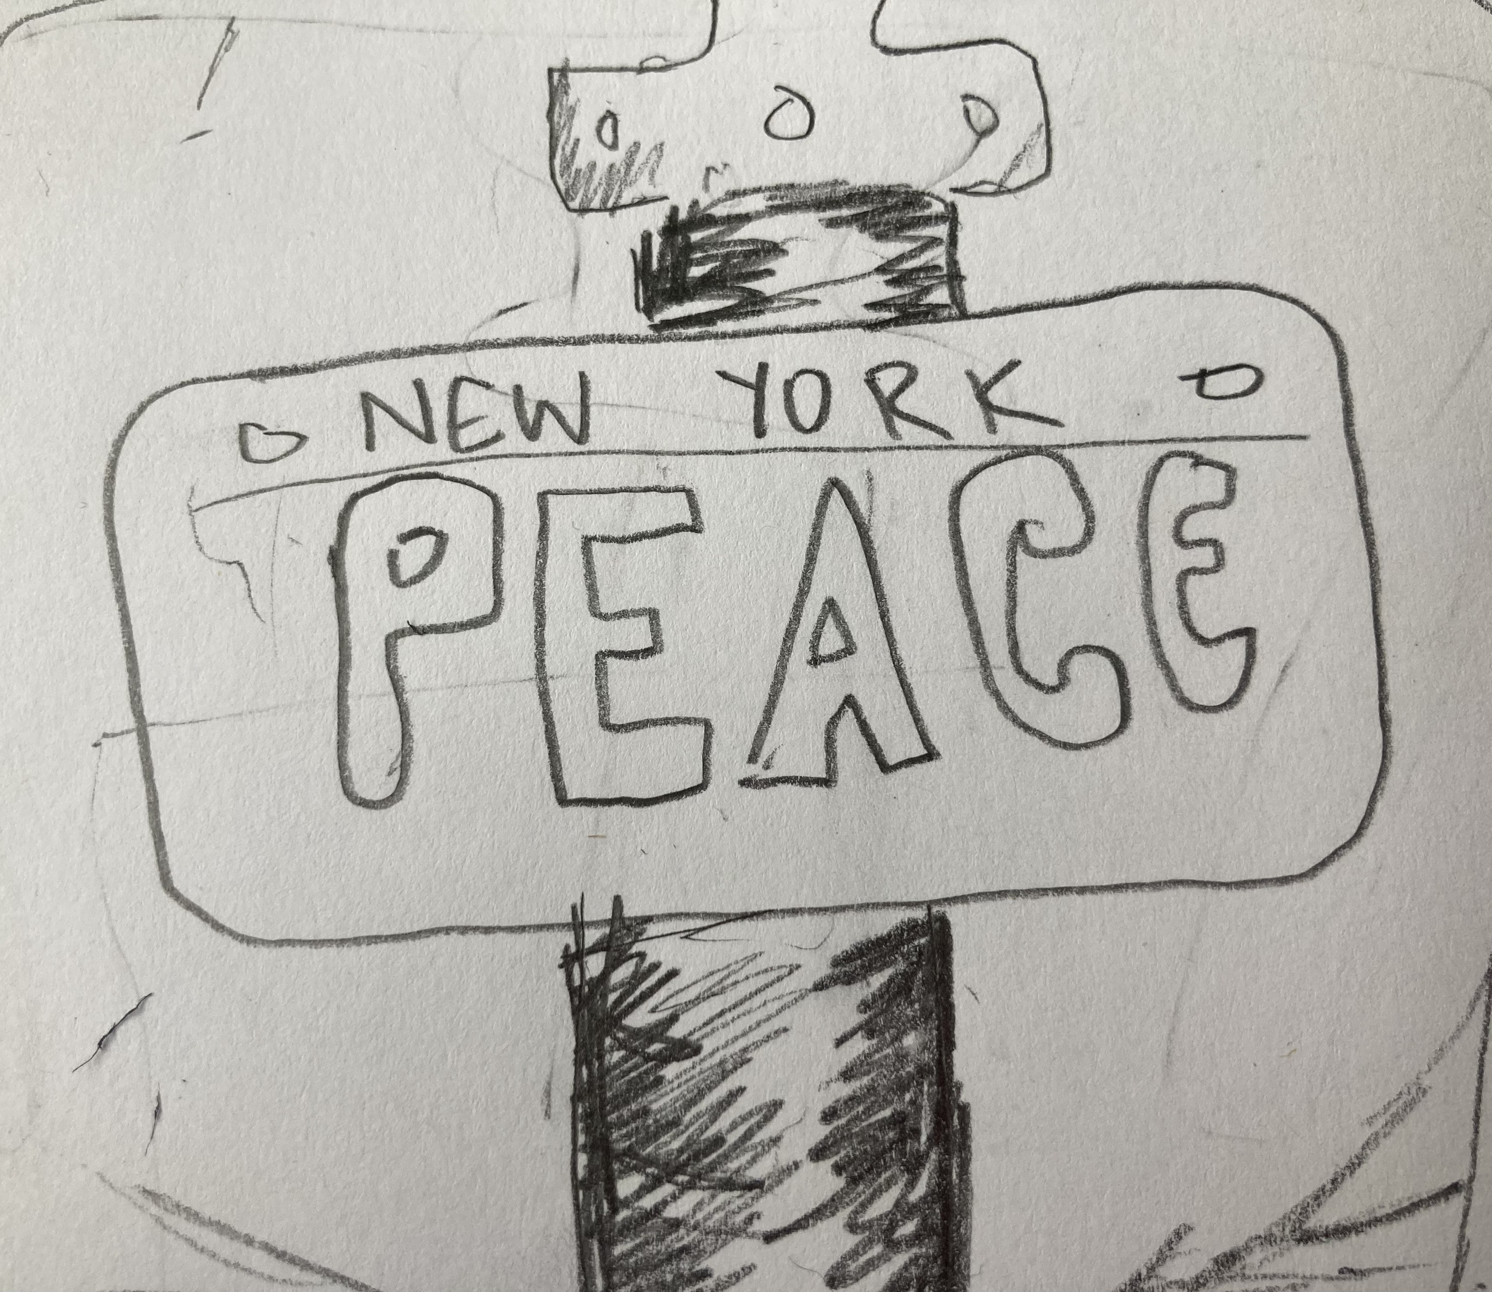
By Banksy Detail by Lou Moonlight

Play “I Think I’ll Call It Morning” by Gil Scott-Heron.

